Agenda Item : 1/02

= application site



The Hive Football Centre, Prince Edwards Playing Fields, Camrose Avenue, Edgware | P/2763/17
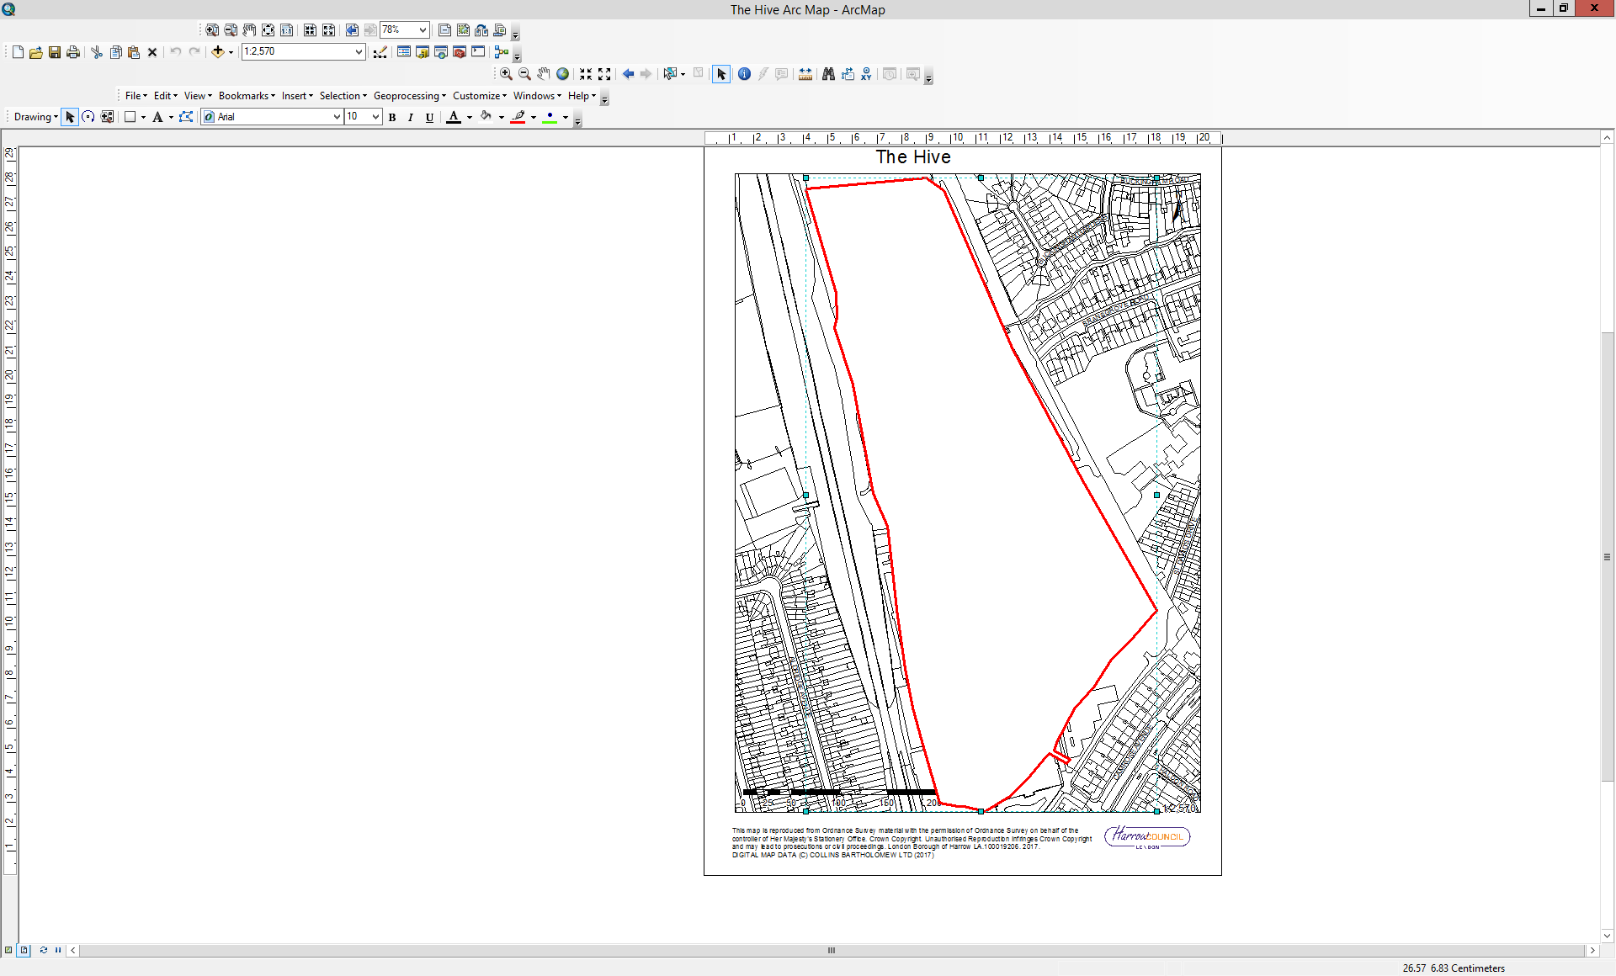

The Hive Football Centre, Prince Edwards Playing Fields, Camrose Avenue, Edgware | P/2763/17

LONDON BOROUGH OF HARROW

PLANNING COMMITTEE

30th May 2018

APPLICATION NUMBER: | P/2763/17
VALIDATE DATE: | 06TH NOVEMBER 2018
LOCATION: | THE HIVE FOOTBALL CENTRE, PRINCE EDWARDS PLAYING FIELDS, CAMROSE AVENUE, EDGWARE
WARD: | QUEENSBURY
POSTCODE: | HA8 6AG
APPLICANT: | THE HIVE FOUNDATION
AGENT: | INDIGO PLANNING
CASE OFFICER: | NIK SMITH
EXPIRY DATE: | EXTENSION OF TIME FOR DETERMINATION AGREED TO 10TH APRIL 2018
PURPOSE OF REPORT

The purpose of this report is to set out the Officer recommendations to the Planning Committee regarding an application for planning permission relating to the following proposal:

Erection of an indoor academy building with an indoor 3G pitch, a new 11-a-side 3G pitch, eight 5-a-side pitches, a new indoor sports hall, a permanent ticket-office and club-shop, a permanent academy spectator stand and WC and snack shop porta cabins.

RECOMMENDATION A

The Planning Committee is asked to:

- agree the reasons for approval as set out in this report including the planning obligations below and the conditions at Appendix 1, and

- delegate authority to the Divisional Director of Regeneration, Enterprise and Planning to issue the planning permission subject to minor amendments to the conditions (set out in Appendix 1 of this report) and/or the Committee resolutions.

Planning Obligations

The committee resolution would include the following obligations:

- Scheme of Community Access

The submission and approval of and compliance with a Scheme of Community Access that would be secured through a s106 agreement and that would obligate the owner to provide the following at the site:

The Academy building

- Priority booking arrangements for at least 500 hours per year during off-peak periods at a reduced rate for selected local groups*.
- Priority booking rights to local schools and clubs who block book the facility for the whole season.
- Secured public access when those facilities are not in use by the football club or selected local groups*.

The 11-a-side Astroturf pitch

- Priority booking arrangements for at least 500 hours per year during off-peak periods at a reduced rate for selected local groups*.
- Priority booking rights to local schools and clubs who block book the facility for the whole season.
- Secured public access when those facilities are not in use by the football club or selected local groups*.

The eight 5-a-side outdoor pitches

- Priority booking arrangements for at least 500 hours per year during off-peak periods at a reduced rate for selected local groups*.
- Priority booking rights to local schools and clubs who block book the facility for the whole season.
- Secured public access when those facilities are not in use by the football club or selected local groups*.

The indoor sports hall

- Priority booking arrangements for at least 500 hours per year during off-peak periods at a reduced rate for selected local groups*.
- Priority booking rights to local schools and clubs who block book the facility for the whole season.
- Secured public access when those facilities are not in use by the football club or selected local groups*.

*Selected local groups would be defined as local schools, those 16 and under and 50 and over, girls and women, lower socio economic groups, ethnic minority groups, people with disabilities, mental health user groups and other specified target groups agreed between the parties.

- Delivery of facilities in advance of the Academy building

A restriction on the ability to commence development on the academy building prior to the 11-a-side and eight 5-a-side pitches having been completed and made available for use.

Recommendation B

To delegate authority to the Divisional Director of Regeneration, Enterprise and Planning to refuse planning permission in the event that a s106 agreement reflecting the planning obligations set out above is not completed within three months (or an extended period agreed by the Local Planning Authority).

REASON FOR THE RECOMMENDATION

Whilst aspects of the proposed development would conflict with policies of the Development Plan, particularly insofar as they relate to the protection of Open Space, the cumulative benefits that the development would bring forward, including subsidised access to sports facilities at the site by community groups, would outweigh those policy conflicts. When taken as a whole, the proposed development would constitute a sustainable form of development for which planning permission should be granted.

INFORMATION

This application is reported to Planning Committee because the approval of aspects of the proposed development would represent a Departure from the Development Plan and the application is for a ‘major development’, and therefore the scheme falls outside of Schedule 1 of the Scheme of Delegation.

Statutory Return Type: | Major Development
Council Interest: | None
GLA Community Infrastructure Levy (CIL) Contribution (provisional): | £555,415
Local CIL requirement: | nil
HUMAN RIGHTS ACT

The provisions of the Human Rights Act 1998 have been taken into account in the processing of the application and the preparation of this report.

EQUALITIES

In determining this planning application the Council has had regard to its equalities obligations including its obligations under section 149 of the Equality Act 2010.

For the purposes of this application there are no adverse equalities issues.

S17 CRIME & DISORDER ACT

Policies 7.3.B and 7.13.B of The London Plan (2016) and Draft London Plan (2017) Policy D10 require that development proposals should maximise building resilience and minimise potential physical risks including measures to deter terrorism. Local Plan Policy DM1 of the Harrow Development Management Policies (2013) requires all new developments to have regard to safety and the measures to reduce crime in the design of development proposal.

These development proposals have been considered in the context of the requirements of those relevant policies. They have not been found to raise issues that are unacceptable or that cannot be managed through the use of planning conditions.

LOCAL GOVERNMENT (ACCESS TO INFORMATION) ACT 1985
BACKGROUND PAPERS USED IN PREPARING THIS REPORT:

- Planning Application
- Statutory Register of Planning Decisions
- Correspondence with Adjoining Occupiers
- Correspondence with Statutory Bodies
- Correspondence with other Council Departments
- National Planning Policy Framework
- London Plan
- Local Plan - Core Strategy, Development Management Policies, SPGs
- Other relevant guidance

ENVRIONMENTAL IMPACT ASSESSMENT

Whilst no Screening Opinion from the Local Planning Authority has been sought in respect of the proposed development, it has been considered in the context of the Environmental Impact Assessment Regulations (2017) and found not to constitute EIA development.

LIST OF ENCLOSURES / APPENDICES:

Officer Report:
Part 1: Planning Application Fact Sheet
Part 2: Officer Assessment
Appendix 1 – Conditions and Informatives
Appendix 2 – Site Plan
Appendix 3 – Site Photographs
Appendix 4 – Plans and Elevations

OFFICER REPORT

PART 1: Planning Application Fact Sheet

The Site

Address | The Hive Football Centre, Prince Edwards Playing Fields, Camrose Avenue, Edgware, HA8 6AG
Applicant | The Hive Foundation
Ward | Queensbury
Local Plan allocation | MOS5: Prince Edwards Playing Fields
Conservation Area | n/a
Listed Building | n/a
Setting of Listed Building | n/a
Building of Local Interest | n/a
Tree Preservation Order | n/a
Other | - Designated Open Space  - RAF Northolt Safeguarding Area  - Flood Zones 2 and 3a  - Critical Drainage Area  - Core Strategy Sub-Area: Kingsbury and Queensbury  - Site of Nature Importance  - PTAL 2 and 3

Uses

Existing Use(s) | Existing Use / Operator | The Hive Football Centre
Existing Use(s) | Existing Use Class(es) sqm | D2 (Assembly and Leisure)
Proposed Use(s) | Proposed Use / Operator | The Hive Football Centre
Proposed Use(s) | Proposed Use Class(es) sqm | D2 (Assembly and Leisure)

Transportation

Car parking | No. Existing Car Parking spaces | 326
Car parking | No. Proposed Car Parking spaces | 326
Public Transport | PTAL Rating | 2 and 3
Public Transport | Closest Rail Stations | Canons Park and Queensbury underground stations
Public Transport | Bus Routes | 79, 186 and 340
Parking Controls | Controlled Parking Zone? | CS (Canons Park Station), DA (Donnefield Avenue), TC (Torbridge Close), BG (Buckingham Gardens) and Q4 (Turner Road) within the vicinity of the site
Parking Controls | CPZ Hours | CS: 0800 – 1830 Mon - Sat  DA: 0800 – 1830 Mon – Sat  TC: 1400 – 1500 Mon - Fri  BG: 1400 – 1500 Mon - Fri  Q4: 1100 – 1200 and 1500 – 1600 Mon - Fri
Refuse/Recycling Collection | Summary of proposed refuse/recycling strategy | Privately managed

Sustainability / Energy

Development complies with Part L 2013? | Yes
Renewable Energy Source | Air source heat pump

PART 2: Assessment

- SITE DESCRIPTION

  - The Hive Football Centre (formerly Prince Edward Playing Fields) comprises former educational sports grounds, designated as Open Space and allocated for Community Outdoor Sports Use. It is now occupied by a football stadium with ancillary facilities and open-air grass and synthetic football pitches. Planning permission has recently been granted for a temporary spectator stand to serve academy pitches at the east of the site. There are two porta cabins at about the mid-point on the east side of a central pathway that runs north to south through the site.

  - The site is bound by the Jubilee Line railway to the west, with residential properties fronting Aldridge Avenue on the other side of the embankment, residential properties fronting Whitchurch Lane to the north and those on Camrose Avenue to the south. Those properties on Camrose Avenue have gardens that adjoin the site, the majority of which have chain mesh means of enclosure. To the south of those gardens, on the other side of a road is a large bund, which limits views into the site and the existing artificial floodlit pitches beyond it. To the east, the site adjoins residential properties along Buckingham Gardens and St David’s Drive and Little Stanmore Nursery, First and Middle Schools.

  - The section of railway embankment that adjoins the western site boundary is identified as a Site of Nature Conservation Importance.

  - Levels at the site fall from the north to the Edgware Brook, which crosses the site, and then rises again to Camrose Avenue.

  - The part of the site adjacent to the Brook is in Flood Zone 3a/3b (including an Environment Agency flood defence bund), with other parts of the site within Flood Zone 2.

  - The main vehicular access to the site is from Camrose Avenue, with secondary access (pedestrian only) from Whitchurch Lane.

  - The football stadium at the site is used by Barnet Football Club, a Football League side. A condition attached to a previous planning consent limits attendance on matchdays to 5,176.

  - There are 326 car parking spaces at the site and space to park ten coaches.

  - The total area of the site is around 17ha.

- THE PROPOSAL

  - Full planning permission is sought for:

  - An Academy building which would replace one of the existing artificial floodlit pitches on the southern edge of the site. It would be used for indoor sport. It would be approximately 123m wide, 74m deep, a minimum of 11m tall and a maximum of 18m tall, with a domed roof form.
  - The re-provision of the 11-a-side artificial floodlit pitch together with eight floodlit 5-a-side pitches between Edgware Brook and the existing north stand of the stadium.
  - A sports hall to the rear of and above the existing north stand. It would be used for indoor sport and would be approximately 114m wide, a minimum of 18 and a maximum of 33m deep and 17.5m tall. It would be located above an existing roadway located to the rear of the north stand so that traffic could continue to pass underneath it.
  - A single-storey club shop/ticket office that would be located to the north of the existing artificial pitches at the south of the site. It would be approximately 25m wide, 4m deep and 3.5m tall.
  - The permanent siting of the temporary academy spectator stand at the west of the site. It would be approximately 14m wide, 10m deep and 7m tall.
  - The replacement of two porta cabins on the east side of the central footpath through the site with permanent single-storey structures.
  - Associated landscaping and replacement coach parking.

Figure 3 – Existing and Proposed Site Plans

Existing
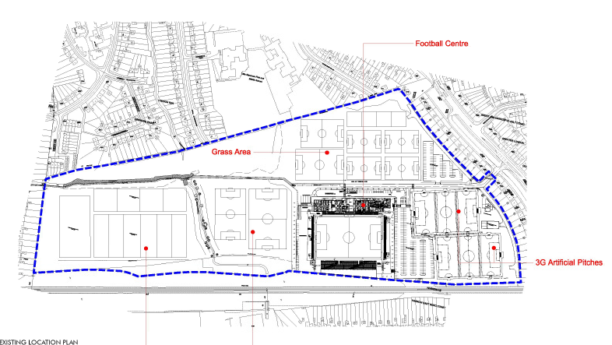

Proposed

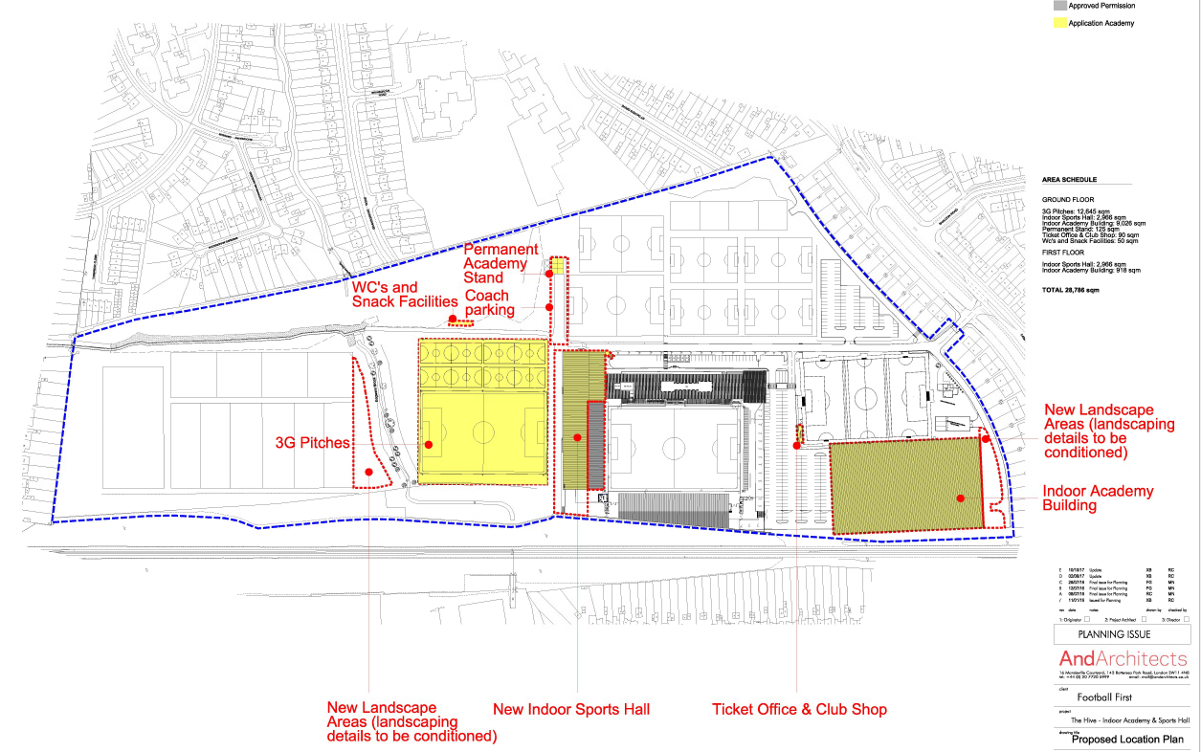

- RELEVANT PLANNING HISTORY

  - A summary of the relevant planning application history for the site is set out in the table below:

Reference | Description | Decision
EAST/148/01/OUT | Outline: football stadium, terraces, stand & clubhouse, floodlights to ground, artificial pitch & tennis courts, health & fitness facilities, parking, vehicular access from Camrose Avenue | Approved: 11th April 2003
P/1087/03/DVA | Variation of condition 13 of planning permission East/148/01/OUT to provide revised parking layout | Approved: 29th July 2003
P/898/03/CDP | Details of design and appearance of building and landscaping pursuant to condition 2 of outline planning perm. East/148/01/OUT for football stadium  associated works | Approved: 04th August 2003
P/0002/07 | Redevelopment for enlarged football stadium and clubhouse, floodlights, games pitches, banqueting facilities, health and fitness facility, internal roads and parking | Approved: 08th April 2008
P/1321/08 | Alterations and internal changes to east stand and change of use of part of first floor of east stand from D2 (assembly and leisure) to primary care trust premises | Approved: 06th October 2008
P/1226/09 | S.73 application to vary condition 27 (development within the area liable to flood) attached to planning permission P/0002/07 | Approved: 25th August 2009
P/2022/09 | Variation of condition 18 (external lighting) pursuant to planning permission ref: P/0002/07/CFU dated 8 April 2008 from 'All exterior lighting other than floodlighting shall be extinguished on any day not later than 22:30 hours, except lighting not more than 1m above the finished road or car park level that shall be extinguished not more than 60 minutes after the end of any match or event' to 'All exterior lighting other than floodlighting shall be extinguished on any day not later than 22:30 hours, except lighting not more than 1m above the finished road and car park level that shall be extinguished not more than 60 minutes after the end of any match or event.' | Approved: 06th November 2009
P/2257/09 | Variation of condition 17 (floodlighting) pursuant to planning permission ref: P/0002/07/CFU dated 8 April 2008 from 'The floodlighting hereby permitted for playing surfaces shall only be used on any day up to 2200 hours except when evening matches are being played at the main stadium when floodlighting shall only be used up to 2300 hours' to 'The floodlighting hereby permitted for playing surfaces shall only be used on any day up to 2300 hours, until commencement of use of the playing surface of the main stadium, at which time floodlighting for the main stadium shall only be used on any day up to 2300 hours, and any other floodlighting within the site hereby permitted for playing surfaces shall only be used on any day up to 2230 hours'. | Refused: 29th December 2009
P/2912/09 | Variation of condition 17 (floodlighting) of planning permission ref: P/0002/07 dated 8 April 2008 from `the floodlighting hereby permitted for playing surfaces shall only be used on any day up to 22.00 hours except when evening matches are being played at the main stadium when floodlighting shall only be used up to 23.00 hours' to `the floodlighting hereby permitted for playing surfaces shall only be used on any day up to 22.30 hours except when evening matches are being played at the main stadium when floodlighting shall only be used up to 23.00 hours'; variation of condition 18 (external lighting) from `all exterior lighting other than floodlighting shall be extinguished on any day not later than 22:30 hours, except lighting not more than 1m above the finished road or car park level that shall be extinguished not more than 60 minutes after the end of any match or event' to `exterior lighting other than floodlighting shall be extinguished on any day not later than 23.00 hours except lighting in the main car park which shall be extinguished not later than 23.30 hours. when holding a match or event, lighting not more than 1m above the finished road and car park lighting shall be extinguished not more than 60 minutes after the end of such match or event' | Approved: 15th June 2010
P/1693/12 | Variation of condition 17 (floodlighting) of planning permission ref: P/0002/07 dated 8 April 2008 from `the floodlighting hereby permitted for playing surfaces shall only be used on any day up to 22.00 hours except when evening matches are being played at the main stadium when floodlighting shall only be used up to 23.00 hours' to `the floodlighting hereby permitted for playing surfaces shall only be used on any day up to 22.30 hours except when evening matches are being played at the main stadium when floodlighting shall only be used up to 23.00 hours'  Variation of condition 18 (external lighting) from `all exterior lighting other than floodlighting shall be extinguished on any day not later than 2230 hours, except lighting not more than 1m above the finished road or car park level that shall be extinguished not more than 60 minutes after the end of any match or event' to `exterior lighting other than floodlighting shall be extinguished on any day not later than 23.00 hours except lighting in the main car park which shall be extinguished not later than 23.30 hours. when holding a match or event, lighting not more than 1m above the finished road and car park lighting shall be extinguished not more than 60 minutes after the end of such match or event' | Approved: 10th September 2012
P/2807/12 | Non-material amendment to add a condition detailing approved plans to planning permission P/0002/07 dated 08/04/2008 for redevelopment for enlarged football stadium and clubhouse, floodlights, games pitches , banqueting facilities, health and fitness facility, internal roads and parking | Approved: 27th November 2012
P/0665/13 | Variation of condition 29 (approved plans - added through application P/2807/12) attached to P/0002/07 dated 08/04/2008 for 'Redevelopment for enlarged football stadium and clubhouse, floodlights, games pitches , banqueting facilities, health and fitness facility, internal roads and parking' to allow minor amendments to the stadium comprising: Phase 1: internal and external alterations to east stand including additional row of seats; increase in height, depth and capacity of west stand including camera position; reduction in capacity of standing areas; increase in height of floodlights and re-siting of southern floodlights; additional turnstiles, spectator circulation, fencing, food kiosks and toilets; alterations to parking areas. Phase 2: replace north stand with seated stand; reduction in capacity of standing area in southern stand; extension to rear of west stand to provide indoor spectator space (total stadium capacity not to exceed 5176 as previously approved) | Refused: 11th September 2013  Appeal allowed: 19th December 2014
P/4092/14 | Single storey side to rear extension to the east stand to create an enlarged medical centre and box office security; provision of two internal chiller units and three internal air conditioning units | Approved: 23rd March 2015
P/4096/14 | First floor side extension to the east stand to create an enlarged banqueting suite and provision of a new entrance | Approved: 13th April 2015
P/2004/15 | Display one internally illuminated free standing sign | Approved: 02nd July 2015
P/2191/15 | Variation of condition 1 (drawing numbers) attached to planning permission P/0665/13 allowed on appeal reference  APP/M5450/A/14/2215248 dated 19/12/2014 to allow for a larger North Stand and associated facilities than that approved by the original consent for an enlarged football stadium and clubhouse, floodlights, games pitches,  banqueting facilities, health and fitness facility, internal roads and parking. Phase 1 involves internal and external  alterations to the East Stand including an additional row of seats, an increase in the height, depth and capacity of the  West Stand, including camera position, reduction in capacity of standing areas, increase in the height of floodlights,  additional turnstiles, spectator circulation, fencing, food kiosks and toilets and alterations to the parking areas. Phase 2 involves the replacement of the North Stand with a seated stand, reduction in the capacity of the standing area in  the South Stand and an extension to the rear of the West Stand to provide indoor spectator space | Approved: 20th July 2015
P/3255/16 | Erection of temporary spectator stand adjacent to the academy pitch (training area a); footpath to provide pedestrian access to the temporary stand | Appeal allowed: 23rd December 2016
P/5204/16 | Variation of condition 1 (drawing numbers) attached to planning  application P/0665/13 allowed on appeal under reference  APP/M5450/A/14/2215248 dated 19/12/2014 to allow for a larger North Stand (increased height and depth, and larger bar area) and the provision of a building to facilitate a ticket office and turnstiles. The scheme allowed on appeal was for an enlarged football stadium and clubhouse, floodlights, games pitches, banqueting facilities, health and fitness facility, internal roads and parking. Phase 1 involved internal and external alterations to the East Stand including an additional row of seats, an increase in the height, depth and capacity of the West Stand, including camera position, reduction in capacity of standing areas, increase in the height of floodlights, additional turnstiles, spectator circulation, fencing, food kiosks and toilets and alterations to the parking areas. Phase 2 involved the replacement of the North Stand with a seated stand, reduction in the capacity of the standing area in the South Stand and an extension to the rear of the West  Stand to provide indoor spectator space extension | Refused: 23rd June 2017  Appeal lodged and decision pending
P/3352/16 | Non-material amendment to planning permission reference P/2191/15 dated 17/07/15 to increase the depth of the north stand at ground floor level, increase the height of the north stand and increase the width of the north stand | Refused: 25th August 2016
P/2764/17 | Erection of a new South stand; new medical facilities, community facilities and commercial floorspace to the rear of the south stand; replacement of East stand seating with terraces; single deck above existing car park and increase in the total capacity of the stadium from 5,176 to 8,500 | Decision pending
P/4485/17 | Variation of Condition 1 (Approved plans) attached to planning permission P/0665/13 allowed on appeal reference APP/M5450/A/14/2215248 dated 19/12/14 to allow for a larger north stand and associated facilities than approved by the original consent | Decision pending

- CONSULTATION

  - Site Notices were displayed at the Whitchurch Lane and Camrose Avenue entrances to the site on 28th November 2017 and 02nd January 2018.

  - Press Notices were displayed in the Harrow Times and the Harrow Observer on the 9th November 2017.

  - The application was advertised as a major application and a departure from the Development Plan.

  - A total of 2,527 consultation letters were sent to neighbouring properties and Resident’s Associations regarding this application.

  - The overall public consultation period expired on 15th February 2018.

Neighbours of the site

Number of letters Sent | 2,527
Number of Responses Received | 18
Number in Support | 0
Number of Objections | 18
Number of other Representations (neither objecting or supporting) | 0

  - Representations received can be summarised as follows:
    - Object to the proposed permanent academy stand
    - The current temporary stand is an eyesore
    - The current youth team does not have enough support to justify the academy stand and it could be used for other purposes
    - There would be more buildings at the site and more people using it
    - There would be more traffic to and from the site and bigger local parking problems
    - The beauty of the field has been taken away
    - There could be anti-social behaviour
    - There would be road safety concerns
    - There would be noise pollution
    - The area is at risk of flooding and the development would make that worse
    - There would be increased footfall to the site
    - There would light and air pollution
    - The site was supposed to be for a training ground
    - There is no benefit to the Council
    - There is an increased police presence on match-days
    - This would be a gross overdevelopment of the site
    - The existing pitches make it difficult to enjoy time in the garden
    - Too many planning applications are submitted at the site
    - The Council should have taken enforcement action previously
    - There should not be a football stadium in a residential area
    - There would be an impact on house prices
    - Infrastructure cannot cope with further expansion at the site
    - Local parking is already problematic

  - These comments are addressed in the main body of this report (other than where they relate to non-planning matters, like potential impact on house prices).

Statutory and Non Statutory Consultees

  - The following consultees were written to by the Planning Authority:
    - Metropolitan Police
    - Sport England
    - London Underground
    - Natural England
    - Environment Agency
    - Ministry of Defence
    - Transport for London
    - Historic England
    - LBH Environmental Health
    - LBH Building Control
    - LBH Highways
    - LBH Biodiversity
    - LBH Street Lighting
    - LBH Drainage

  - A summary of responses received along with the comments are set out in the Table below:

Consultee | Response | Comments
Sport England | No objection subject to conditions | Conditions attached
TfL | No objection subject to condition | Condition attached
Natural England | No comment | Noted
Historic England (Archaeology) | No archaeological requirement | Noted
Environment Agency | No objection subject to conditions | Conditions attached
LBH Highways | No objection | Noted
LBH Drainage | No objections subject to conditions | Conditions attached
LBH Building Control | No objection | Noted

- POLICIES

  - Section 38(6) of the Planning and Compulsory Purchase Act 2004 requires that planning decisions must be made in accordance with the Development Plan unless material considerations indicate otherwise.

  - The Government has issued the National Planning Policy Framework (2012) (NPPF) which consolidates national planning policy and is a material consideration in the determination of this application. The National Planning Practice Guidance (NPPG) provides clarification on interpretation of the policies contained within the NPPF. A draft Emerging replacement National Planning Policy Framework is currently being consulted upon. The weight that should be attached to it is currently limited.

  - The Development Plan is made up of the London Plan (2016) and the Local Development Framework (LDF). The LDF comprises The Harrow Core Strategy (2012), the Harrow and Wealdstone Area Action Plan (2013), the Development Management Policies Local Plan (2013), the Site Allocations Local Plan (2013) and Harrow Local Area Map (2013).

  - The emerging Draft London Plan was published on 29th November 2017. The current Plan still forms part of the Development Plan. The Draft London Plan is a material consideration in planning decisions. It will gain weight as it moves through the process to adoption and the weight given to policies within it is a matter for the decision maker. The Draft London Plan consultation has now closed, with Examination in Public expected in autumn 2018.

  - A full list of all the policies used in the consideration of this application is provided as Informative 1 in Appendix 1 of this report.

- ASSESSMENT

    - The main issues are:
    - Principle of the Development
    - Character and Appearance of the Area
    - Residential Amenity
    - Transport and Parking
    - Flood Risk and Drainage
    - Accessibility, Inclusive Design and Lifetime Neighbourhoods
    - Trees and Biodiversity
    - Energy and Sustainability
    - Infrastructure and Planning Obligations

PRINCIPLE OF DEVELOPMENT

  - The National Planning Policy Framework outlines that the purpose of the planning system is to contribute to the achievement of sustainable development. In order to achieve sustainable development, economic, social and environmental gains should be sought jointly.

  - The NPPF acknowledges the importance of providing access to communities to new sporting facilities and of protecting open space from harmful development.

  - Paragraph 73 sets out that access to high quality open spaces and opportunities for sport and recreation can make an important contribution to the health and well-being of communities. Existing open space, sports and recreational buildings and land, including playing fields, should not be built on unless:
    - an assessment has been undertaken which has clearly shown the open space, buildings or land to be surplus to requirements; or
    - the loss resulting from the proposed development would be replaced by equivalent or better provision in terms of quantity and quality in a suitable location; or
    - the development is for alternative sports and recreational provision, the needs for which clearly outweigh the loss.

  - The site is allocated as Open Space. In order to understand whether the principle of the proposed development would be acceptable, it is necessary to understand whether aspects of the development would conflict with policies that seek to protect open space. If they do, an assessment then needs to be made as to whether the provision of community sporting facilities would constitute a material consideration that should outweigh any such conflicts in the planning balance.

Open Space

  - London Plan Policy 7.18 (Protecting Open Space and Addressing Deficiency) states that the loss of protected open spaces must be resisted unless equivalent or better-quality provision is made within the local catchment area.
  - Policy DM18 (Protection of Open Space) of the Development Management Policies states that land identified as open space on the Harrow Policies Map will not be released for development. Proposals for ancillary development on land identified as open space on the Harrow Policies Map will be supported where:
    - It is necessary to or would facilitate the proper functioning of the open space;
    - It is ancillary to the use(s) of the open space;
    - It would be appropriate in scale;
    - It would not detract from the open character of the site or surroundings;
    - It would not be detrimental to any other function that the open space performs; and
    - There would be no harm to the quality or proper functioning of the open space as a result of the proposal.

The Academy building

  - The introduction of a building of the proposed scale and design in this location would conflict with policies that seek to protect Open Space. It would have a large footprint and would be tall and whilst located in the southwest corner of the site, adjacent to the railway embankment where its impact might be the least harmful at the site, it would result in a substantial built introduction to the site, to the detriment of its openness. It would highly visible from within and beyond the site.

  - Policy DM18 can accommodate the release of Open Space for development subject to criteria, where it would be ancillary to the use or uses for the site. Given the scale and nature of the building, it could not be considered ancillary to the allocated use of the site for outdoor community sport given that it would provide indoor facilities or the football stadium. In any event, the structure would fail to meet the criteria set out in the policy because at the least, it would detract from the open character of the site and its surroundings. The principle of this aspect of the development would be unacceptable. Planning permission should only be granted if other material considerations outweigh that conflict. Whether that would be the case is considered later in this report.

The Sports Hall

  - The proposed sports hall building, to the north of the existing north stand would technically conflict with Open Space protection policies in that it would constitute built development on designated Open Space. It would not be ancillary to either the football stadium or community open space uses at the site. It would, though, not result in the loss of any green space at the site (it would be constructed above existing hardstanding) and it would only be viewed against the backdrop of the existing stadium, which is a substantial building. Whilst a large structure, it would not cause serious harm to the openness of the site on account of its location. Whilst this aspect of the proposed development would conflict with relevant development plan polices, the harm caused by that conflict would be limited. This will need to be weighed against the benefits associated with the development, which are described later in this report.

The permanent academy spectator stand

  - When temporary planning permission was granted for a stand in this location (P/3255/16 – appeal allowed in December 2016), the Inspector found that the stand would fulfil an ancillary function to the uses of the site and that it would meet the criteria set out in Policy DM18. A temporary three year consent was issued then, in part because that is what planning permission had been sought for. Given that an Inspector found the principle of the stand acceptable at that time, and that there have been no material changes in circumstances since that time that should result in a different conclusion being reached now, the principle of this aspect of the development should be found acceptable.

The replacement floodlit Astro turf pitch and the floodlit 5-a-side pitches

  - Whilst elements of these developments would conflict with policies that seek to protect Open Space (fencing and floodlighting in particular), additional playing pitches would form an ancillary function to the community outdoor sports use of the site. They would facilitate the proper functioning of the open space, would be appropriate in scale, would not detract from the open character of the site or its surroundings, would not be detrimental to the football stadium function of the site and would not cause harm to the quality or proper functioning of the open space. As a result, the principle of additional outdoor pitches at the site would be acceptable. The potential impact of floodlighting at the site is considered later in this report.

The club shop/ticket office, coach parking and WC/snack bar structures

  - These facilities would result in the loss of a relatively modest level of open space at the site but they would be ancillary to its football stadium use. Given their scale and location (the clubshop/ticket office building would be located on existing hardstanding), they would not cause serious harm to the openness of the site when taken as a whole. They would facilitate the proper functioning of the open space as a football stadium with supporting facilities, would be appropriate in scale, would not be detrimental to the community outdoor public space function of the site and would not cause harm to the quality or proper functioning of the open space. As a result, the principle of these ancillary structures at the site would be acceptable.

Open Space Summary

  - Whilst the pitches, academy stand and ancillary buildings would be acceptable in principle, the academy building and the sports hall would conflict with Open Space protection policies. The harm caused to openness at the site by the sports hall would be modest and, taken together with the overall improvements and benefits associated with the proposals, these constitute a material consideration in favour of supporting the proposals as set out in this report. It is now necessary to review the policy support for the provision of additional sporting facilities at this site and in general to understand whether that should outweigh conflicts caused by the proposed Academy building with development plan policies seeking to protect Open Space in the planning balance.

The provision of sports facilities at the site

  - London Plan Policy 3.19 (Sports Facilities) states that development proposals that increase or enhance the provision of sports and recreation facilities will be supported. Where sports facilities developments are proposed on existing open space, they will need to be considered carefully in light of policies on protecting open space.

  - Policy MOS5 of the Site Allocations Local Plan allocates the site for community outdoor sports use. The commentary to that policy states that this allocation supports such further outdoor sport development as may be required to enable the success of this important community facility. Development must make provision for community access to facilities and be consistent, in terms of design, siting and any other impacts, with the amenity of neighbouring residential occupiers.

  - The site is designated by the Core Strategy is falling within the Kingsbury and Queensbury Sub-Area. Two of the area objectives for that sub-area are to:
    - Continue to promote Prince Edward playing fields as a centre of sports excellence; and
    - Maintain community access to sport and recreation facilities and encourage enhancement

  - Policy DM46 (New Community, Sport and Education Facilities) states that proposals for the provision of new community, sport and educational facilities will be supported where:
    - They are located within the community that they are intended to serve;
    - They are safe and located in an area of good public transport accessibility or in town centres;
    - There would be no adverse impact on residential amenity.

  - It states that new indoor sport development should make provision for community access to the facilities provided.

  - Policy DM48 (Enhancing Outdoor Sport Facilities) states that proposals that would increase the capacity and quality of outdoor sport facilities, and those that would secure community access to private facilities, will be supported provided that:
    - There would be no conflict with Green Belt, Metropolitan Open Land and open space policies;
    - The proposal would not be detrimental to any heritage or biodiversity assets within or surrounding the site;
    - There would be no adverse impact on residential amenity or highways safety

  - Proposals for floodlighting will be supported where it would enhance sport facilities and would not be detrimental to the character of the open land, the amenity of neighbouring occupiers nor harmful to biodiversity.

  - There is a clear thrust in policy at all levels to provide high quality, new sporting facilities. Whilst it is clear this policy framework acknowledges potential conflicts with Open Space protection policies and seeks to limit those, there is a clear focus on the delivery of new sporting facilities, particularly when they are designed to serve the community within which they are located. The Council’s Core Strategy seeks to promote Prince Edward playing fields as a centre of sports excellence; and enhance recreation facilities there.

  - The development would result in substantial indoor, multi-use sporting facilities. Being indoor, they would have the benefit of being useable all year round. In addition, a replacement 11-a-side Astroturf pitch and eight new 5-a-side pitches would be provided at the site. Together, the facilities would represent a substantial provision of new, accessible sporting facilities to which positive weight should be afforded.

  - That provision, in itself, though, would not justify departing from the Open Space protection policies described previously. That is because London Plan Policy 3.19 and Policy DM48 both seek to avoid harm being caused to Open Space by new sporting facilities. The weight that can be attached to the delivery of new facilities in accordance with those policies must be reduced by the identified harm that would be caused by the Academy in particular to the designated Open Space.

  - In order that significant weight can be attached to the provision of new sporting facilities, the community must be able to access them. In this case, the applicant has confirmed that all of the new facilities will be made available for booking when not in use by the football club. That is likely to be most off-peak times of the day and through the summer, when the football club does not train. These new facilities, given their quantum and flexibility, would provide a genuine benefit for local people and substantial weight should be given to that benefit in the planning balance.

  - In addition, the applicant has committed to enter into a legal agreement which would secure priority booking arrangements for selected local groups at discounted rates for at least 500 hours per year for each of the new facilities. These local groups would include local schools, those 16 and under and 50 and over, girls and women, lower socio economic groups, ethnic minority groups, people with disabilities and mental health user groups.

  - Priority, discounted booking would also be provided for local clubs and schools who block booked the facilities.

  - The mechanism for securing that priority provision would be addressed in a legal agreement.

  - This would constitute a substantial community benefit and would get to the heart of the site’s allocation for community sport. Taken together with the intrinsic benefit of providing new sporting facilities in the borough, these public benefits would outweigh the identified conflicts with Open Space protection policies set out in this report.

  - Planning applications should be determined in accordance with policies of the development plan unless material considerations indicate otherwise. These benefits would constitute material planning considerations that indicate that a planning decision should be made other than in accordance with development plan policies relating to Open Space.

  - A planning obligation would prevent the Academy building coming forward in advance of the new pitches so as to ensure that the benefit was realised before harm to the Open Space occurred. The applicant has explained that it would not be feasible to deliver the sports hall in advance of the Academy because of funding arrangements for it. That explanation is accepted.

  - On balance, the principle of the development, when taken as a whole would be acceptable.

CHARACTER AND APPEARANCE OF THE AREA

  - The NPPF states that good quality design is an integral part of sustainable development and that decision takers should always seek high quality design. It states that achieving good design is about creating places, buildings or spaces that work well for everyone, look good, will last well, and adapt to the needs of future generations, with good design responding in a practical and creative way to both the function and identity of a place, putting land, water, drainage, energy, community, economic, infrastructure and other such resources to the best possible use. The NPPF also says permission should be refused for development of poor design that fails to take the opportunities available for improving the character and quality of an area and the way it functions. It is proper to seek to promote or reinforce local distinctiveness.

  - Planning permission should not be refused for buildings and infrastructure that promote high levels of sustainability because of concern about incompatibility with an existing townscape, if mitigated by good design.

  - The degree to which new development reflects and responds to the character and history of its surrounds is a key element of good design as defined within the NPPF. This relationship should be considered throughout the design process, and should inform the positioning, massing, height, and materiality of development proposals. Developing a design solution that works with its surrounding context should not prevent or discourage appropriate innovation.

  - The London Plan requires all large scale proposals to be of the highest quality design especially in terms of impact on views, the wider and local townscape context and local environmental impact. The achievement of high quality urban design is also highlighted as a key factor in achieving a more attractive and green city.

  - London Plan Policy 7.4 (Local Character) sets out that buildings should provide a high quality design response to the urban grain, street pattern, natural features, human scale and the historic environment and is supported by Policy 7.6 (Architecture) which seeks to promote high architectural and design quality appropriate to its context.

  - Policy 7.6 (Architecture) states that buildings and structures should:
  - be of the highest architectural quality
  - be of a proportion, composition, scale and orientation that enhances, activates and appropriately defines the public realm
  - comprise details and materials that complement, not necessarily replicate, the local architectural character
  - not cause unacceptable harm to the amenity of surrounding land and buildings, particularly residential buildings, in relation to privacy, overshadowing, wind and microclimate. This is particularly important for tall buildings
  - incorporate best practice in resource management and climate change mitigation and adaptation
  - provide high quality indoor and outdoor spaces and integrate well with the surrounding streets and open spaces
  - be adaptable to different activities and land uses, particularly at ground level
  - meet the principles of inclusive design
  - optimise the potential of sites

  - Policy CS1 of the Council’s Core Strategy states that all development shall respond positively to the local and historic context in terms of design, siting, density and spacing, reinforce the positive attributes of local distinctiveness.

  - Policy DM1 states that all development must achieve a high standard of design and layout. Proposals which fail to achieve this, or which are detrimental to local character and appearance will be resisted.

  - The assessment of the design and layout of proposals will have regard to:
  - The massing, bulk, scale and height of proposed buildings in relation to the location, the surroundings and any impact on neighbouring properties
  - The appearance of proposed buildings, including but not limited to architectural inspiration, detailing, roof form, materials and colour, entrances, windows and the discreet accommodation of external services
  - The context provided by neighbouring buildings and the local character and pattern of development
  - The provision of appropriate space around buildings for setting and landscaping, as a resource for occupiers and to secure privacy and amenity;
  - The need to retain or enhance existing landscaping, trees, biodiversity or other natural features of merit
  - The functionality of the development including but not limited to the convenience and safety of internal circulation, parking and servicing (without dominating the appearance of the development) and the appearance, capacity, convenience, logistics and potential nuisance of arrangements for waste, recycling and composting
  - The arrangements for safe, sustainable and inclusive access and movement to and within the site.

  - The Council’s Residential Design Guide SPD (2010) provides further guidance on how developments can achieve good design.

The Academy building

  - Aside from the impact of the building on the openness of the space, and whilst the building would be large, it would be of an acceptable appearance for its use. It would relate reasonably well to the emerging character of the site and would be located in the least visually sensitive area of it. It would largely be viewed in the context of the car parking areas and the stadium which have a more urban character. Materials would be secured by condition.

The sports hall

  - Whilst a substantial addition to the site, the extensions to the north stand would be seen in the context of the stadium, where it would not appear dominating or out of place. Materials would be secured by condition.

The new pitches

  - Whilst the introduction of fencing and floodlighting would introduce a more urban form of development into the centre of the site, which is currently grassed, facilities like this would not appear inappropriate in this location, particularly in the context of the site’s allocation for outdoor sport.

The academy stand

  - When temporary planning permission was granted by a planning inspector for this development in 2016, they found its appearance in the context of the site to be acceptable. There have been no material changes in circumstances that should alter that conclusion at this time.

The club shop/ticket office and WC/snack shop buildings

  - These single-storey structures would be modest in scale and appearance in the context of the wider site. They would appear ancillary and would not detract from the appearance of the site as a whole.

Summary

  - The appearance of the development overall would be acceptable.

RESIDENTIAL AMENITY

  - The NPPF sets out as one of its core planning principles at paragraph 17 that planning should always seek to secure a good standard of amenity for existing occupants.

  - London Plan policy 7.6 states that buildings and structures should not cause unacceptable harm to the amenity of surrounding land and buildings, particularly residential buildings, in relation to privacy, overshadowing, wind and microclimate.
  - Policy DM1 states that proposals that would be detrimental to the privacy and amenity of neighbouring occupiers will be resisted. The assessment of privacy and amenity considerations will have regard to:
  - The prevailing character of privacy and amenity in the area and the need to make effective use of land;
  - The overlooking relationship between windows and outdoor spaces;
  - The distances between facing windows to habitable rooms and kitchens
  - The relationship between buildings and site boundaries
  - The visual impact of development when viewed from within buildings and outdoor spaces
  - The adequacy of light and outlook within buildings (habitable rooms and kitchens) and outdoor spaces
  - The adequacy of the internal layout of buildings in relation to the needs of future occupiers and any impact on neighbouring occupiers
  - The impact of proposed use and activity upon noise, including hours of operation, vibration, dust, air quality and light pollution
  - The need to provide a satisfactory quantum and form of amenity space for future occupiers of residential development

  - The Council’s Residential Design Guide SPD (2010) (at NS17) is a material planning consideration. It states that the size and siting of buildings must avoid unreasonable loss of light to, or overshadowing of, adjoining buildings and spaces. Developments which have an overbearing visual impact will not be acceptable.

  - It says that the relationship between buildings is a significant determinant of the amenity enjoyed by residents. The proximity, orientation and size of one building can impact upon the light, outlook and visual environment of occupiers of an adjoining building.

  - Policy DM 41(Evening Economy) includes criteria requiring the consideration of impacts of uses proposed upon neighbouring residential occupiers. Policy DM 1 (Achieving a High Standard of Development) requires consideration of the amenity impact of a proposed use/activity in terms noise (including hours of operation), vibration, dust, air quality and light pollution.

The Academy building

  - The building would be large and prominent. Given its location at the site, in the southwest corner, it would be very visible. Neighbours to the south that front Camrose Avenue would be able to see the building clearly from their rear facing windows and from their rear gardens. Most properties that adjoin the site to the south have chain link fencing as boundary treatment which would amplify visibility.

  - The structure would be around 14m away at its nearest point to the boundaries with gardens to the south (No’s 292 and 294). At that point, the building would be at its lowest (around 11m tall) and the view from those gardens would be more open than just the new building. The distance between the Academy and the nearest garden at the point that the building was at its tallest (around 18m in height at the centre), would be around 23m. The distance between the building and the edge of the gardens would increase to the west of No 292 and 294, to a maximum of around 24m. The distance between the building and the rear elevation of houses to the south would be a minimum of 30m and in most cases, more than that.

  - Sections taken through the building and adjoining neighbours of the site are shown below:
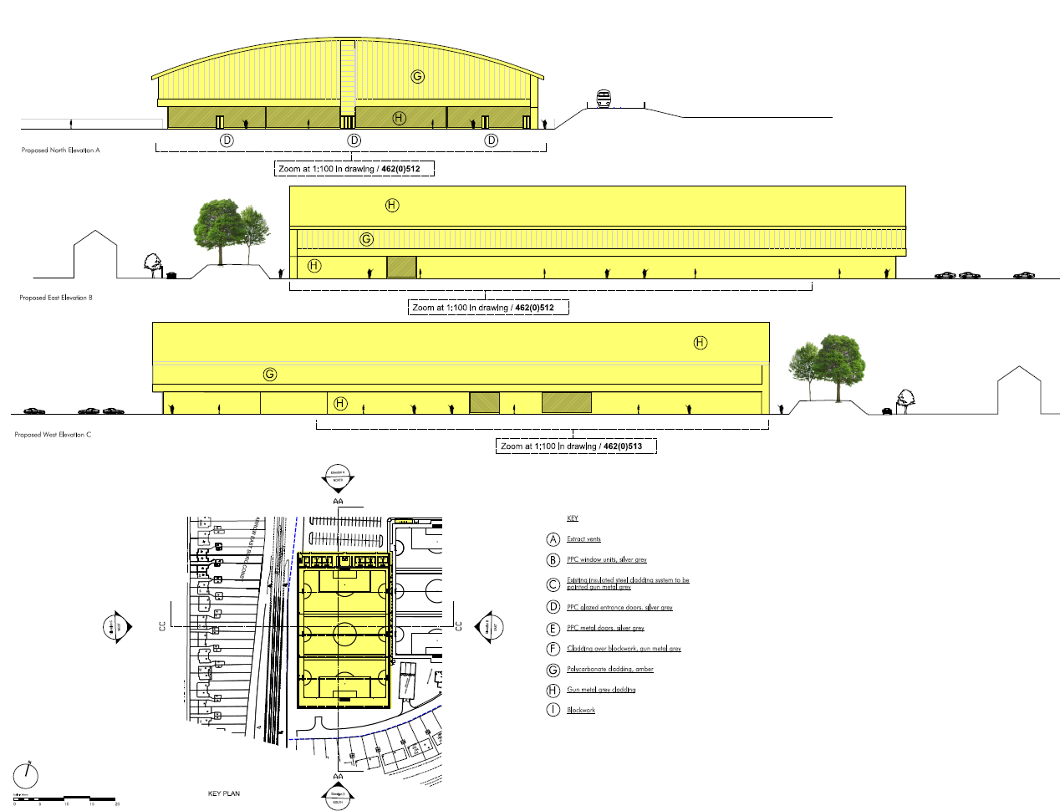

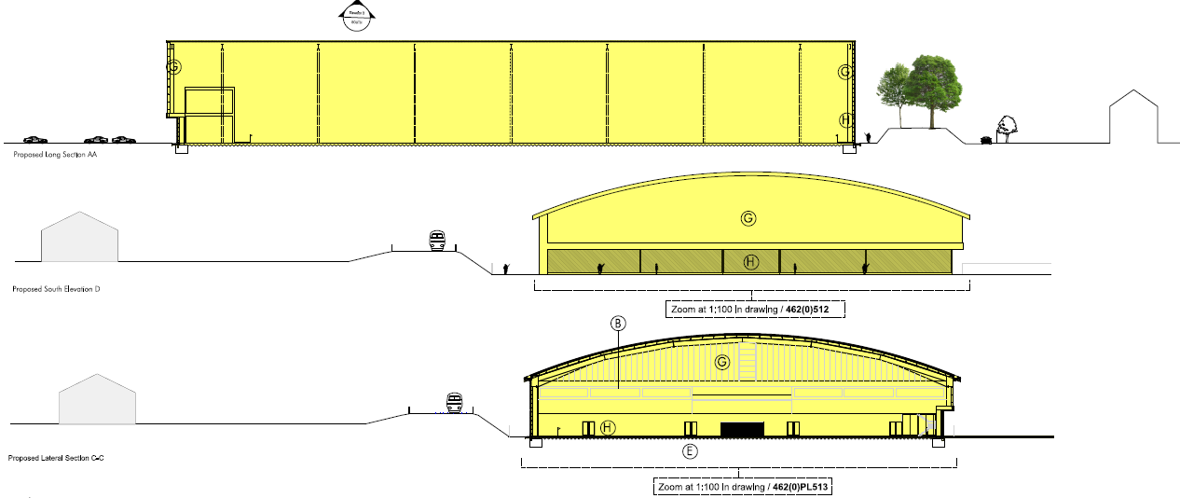

  - There is a substantial earth, grassed bund between those gardens and the proposed site of the building. That would assist in reducing its visual impact. Views from the back of the gardens is currently of the bund, which restricts views over the site. A condition would require details of landscaping of the bund, which would soften the appearance of the structure – albeit over time as it matures.

  - Owing to the distances described and the orientation (it would be to the north of the gardens), there would be no serious loss of sunlight or daylight or the introduction of shadowing. The development would not be overbearing to an extent that should lessen the enjoyment of habitable rooms or gardens. Outlook would change, but it is already limited to an extent by the siting of the bund.

  - Clearly, a building of this scale in this location would be very visible for existing neighbours to the south, in particular, but it would not result in harm in terms of loss of amenity to living conditions to an extent that should justify the refusal of planning permission.

  - Neighbours to the west on Aldridge Avenue would experience a comparable relationship, albeit lessened by the presence of the railway and its embankments and the lower eaves section of the proposed building running for the length of the western elevation.

  - The enclosure of one of the currently outdoor pitches with the structure would result in noise and light that might be associated with an outdoor pitch being lessened, which some neighbours might consider an improvement against the existing situation.

The sports hall, stand and ancillary structures

  - The location and use of the sports hall (which whilst a large structure, would be further away from neighbours than existing elements of the stadium), the academy spectator stand and the ancillary single storey structures would prevent harm being caused by them to living conditions at neighbouring properties. The sports hall would be no nearer to neighbours to the west than the existing west stand at the stadium. When the Inspector granted consent for the temporary academy spectator stand at the site, he found the impact on neighbours to be acceptable, and that would continue to be the case with a permanent stand in this location.

Noise and floodlighting – the proposed outdoor pitches

  - The application is supported by an Acoustic Assessment which concludes that the proposed academy building would be expected to reduce noise levels for existing neighbours to the west and south because one of the currently outdoor pitches would be enclosed by a structure. The provision of the sports hall would result in little or no change to noise exposure. The relocation of some sports pitches within the site could result in a marginal increase in noise levels, because outdoor sport would be taking place at different parts of the site. Given the outdoor sport allocation of the site, activity associated with it, subject to controls, would be appropriate in this location.

  - The external pitches at the site would be served by floodlighting. The application is supported by a Lighting Statement which concludes that the impact on neighbouring residents would be minimised as overspill values into gardens and windows would be below recommended values. Daytime visual impact would be minimised through the use of slim line masts and light grey floodlights.

  - Planning conditions would seek to minimise the potential impacts of noise and floodlighting. The Council’s Environmental Health Team has reviewed the submitted technical reports and have raised no objection to the planning application. Planning conditions would control the hours where floodlighting could be used to minimise impact on neighbours during night time hours.

Summary

  - Subject to planning conditions, the impacts of the development on living conditions at neighbouring properties to the site would be acceptable.

TRANSPORT AND PARKING

  - The NPPF emphasises the importance of reducing the need to travel, and encouraging public transport provision to secure new sustainable patterns of transport use. It says that development proposals should not be refused on transport grounds unless the impacts of a development would be severe.

  - London Plan policies 6.3, 6.9 and 6.13 seek to regulate parking in order to minimise additional car travel, reduce trip lengths and encourage use of other, more sustainable means of travel.

  - Policy DM42 (Parking Standards) prescribes the amount of car parking that should be provided at a site, depending on its use.

  - The application is supported by a Transport Assessment that concludes that the site is well served by public transport, is served by local pedestrian and cycle links and has on-site car parking.

  - Coach parking spaces that would be lost as a result of the development would be replaced within the site, to the satisfaction of the Local Highways Authority.

  - Given the nature of the proposed facilities, it is unlikely that they would result in new vehicular trips to the site in quantities that could have a severe impact on the local highways network. The applicant’s Transport Assessment sets out that whilst the new facilities at the site could attract a larger number of visitors to the site, this could be accommodated within the existing capacity of existing roads and junctions. There is a large number of car parking at the site which would adequately serve the proposals.

  - The Local Highways Authority is satisfied that the traffic and parking implications of the proposed development would be acceptable.

FLOOD RISK AND DRAINAGE

  - London Plan Policy 5.12 (Flood Risk Management) states that development proposals must have regard to measures proposed in Catchment Flood Management Plans. The Environment Agency Thames Catchment Flood Management Plan (2009) focuses on the adaptation of the urban environment to increase resistance and resilience to flood water. This objective informed the preparation of Harrow’s Local Plan policies on flood risk management.

  - Core Strategy Policy CS1 U undertakes to manage development to achieve an overall reduction in flood risk and increased resilience to flood events.
  - London Plan Policy 5.13 states that development should utilise sustainable urban drainage systems (SUDS) and should aim to achieve greenfield run-off rates.

  - Policies DM9 (Sustainable Flood Risk Management) and DM10 (On-Site Water Management and Surface Water Attenuation) call for major development to reduce surface water run-off; utilise sustainable drainage systems; ensure adequate arrangements for management and maintenance of on-site infrastructure; use appropriate measures to prevent water pollution; and where appropriate, demonstrate that the proposal would be resistant and resilient to flooding from all sources.

  - The application is supported by a Flood Risk Assessment. It describes that the Environment Agency Flood Zone mapping and modelled flood data for the Edgware Brook shows that areas at the site are located across all three flood zones. The proposed uses of each area of the site have been assessed against the land uses allowed in each flood zone and have been found to be acceptable. Other forms of flooding been assessed to present risk of flooding to the site and so mitigation measures are proposed to reduce these risks.

  - Existing drainage systems relating to earlier developments at the site have been approved by the Council and the Environment Agency. The proposed development would not result in flow rates above those previously agreed. Appropriate surface water attenuation storage would be provided at the site and would be controlled by planning conditions.

  - The Council’s Drainage Team and the Environment Agency are satisfied that subject to planning conditions, the flood risk and drainage implications of the development would be acceptable.

ACCESSIBILITY, INCLUSIVE DESIGN AND LIFETIME NEIGHBOURHOODS

  - London Plan Policy 7.1 (Lifetime Neighbourhoods) requires development to improve people’s access to social and community infrastructure, shops, services, employment opportunities and public transport; contribute to healthy, active lives, social inclusion and cohesion, and people’s sense of place, safety and security; and reinforce the character, legibility, permeability and accessibility of the neighbourhood.

  - Policy DM2 (Achieving Lifetime Neighbourhoods) requires the location, design and layout of development, and any associated improvements to the public realm, transport and other infrastructure, to contribute to the creation of lifetime neighbourhoods. In particular it calls for:
    - non-residential development to be located to sustain town centres and local employment opportunities, and to be accessible to all;
    - new residential development to ensure good access to services and facilities, and to provide accessible homes;
    - all proposals to be safe and secure in accordance with Secured by Design principles; major proposals to demonstrate how they contribute to lifetime neighbourhoods within and beyond the site boundary;
    - improvements to the public realm must achieve an inclusive, legible pedestrian and cycling environment; and
    - accessible bus stops and provision of car parking for disabled people;
    - major development within town centres to make provision for the comfort and convenience of all users.

  - Policy DM1 (Achieving a High Standard of Development) calls for all proposals to achieve a high standard of design and layout and sets out a range of relevant criteria, including (g) arrangements for safe, sustainable and inclusive access and movement to and within the site.

  - Policy DM2 (Achieving Lifetime Neighbourhoods) requires the location, design and layout of development, and any associated improvements to the public realm, transport and other infrastructure, to contribute to the creation of lifetime neighbourhoods. This policy is supported by guidance in the Access for All Supplementary Planning Document.

  - The site is in a sustainable location, would be of a sufficiently high quality design and would secure the delivery of new sporting facilities that would provide community value for local people. A planning obligation would secure access to the facilities at a discounted rate for those groups traditionally less likely to access sporting facilities like those proposed.

TREES, LANDSCAPING AND BIODIVERSITY
Trees and landscaping

  - London Plan Policy 7.21 (Trees and Woodland) states that existing trees of value should be retained and that, wherever appropriate, additional trees should be planted in new development.

  - Policy DM22 Trees and Landscaping requires development proposals to include hard and soft landscaping and calls for retained trees to be protected during construction.

  - None of the trees on the site are subject to a Tree Preservation Order (TPOs) or Conservation Area designations. It is not proposed to remove any trees from the site.

  - A planning condition would seek to secure the protection of existing trees at the site.

  - The extent of new built development that would be introduced to the site enhances the need for new, high quality landscaping at the site. This would be secured by way of a planning condition.

Biodiversity

  - The NPPF sets out the principles for conserving and enhancing biodiversity, which include resisting development that would:
    - cause significant harm that cannot be avoided, mitigated or compensated-for; or
    - have an adverse effect on a Site of Special Scientific Interest (SSSI). Opportunities to incorporate biodiversity in and around developments are encouraged.

  - London Plan Policies 5.10 (Urban Greening) and 5.11 (Green Roofs and Development Site Environs) call for the provision of green infrastructure on site, including planting, green roofs and green walls.

  - London Plan Policy 7.19 Biodiversity and Access to Nature echoes the need for development proposals to make a positive contribution to biodiversity, to protect statutory sites, species and habitats, and to help achieve Biodiversity Action Plan targets.

  - Policy DM20 (Protection of Biodiversity and Access to Nature) makes clear that proposals that would be detrimental to locally important biodiversity or that would increase local deficiencies will be resisted.

  - Policy DM 21 (Enhancement of biodiversity and access to nature) encourages improvements to biodiversity, including the incorporation of techniques to enhance biodiversity – such as green roofs and green walls.

  - The application is supported by an Ecological Assessment of the site. It concludes that subject to mitigation measures, the impact of the development on existing biodiversity at the site would be acceptable. The development would not result in harm to protected species. Planning conditions would seek to protect existing biodiversity and secure a net-gain in value at the site.

ENERGY AND SUSTAINABILITY

  - Section 10 of the NPPF seeks to promote low carbon and renewable energy, including decentralised energy. This includes requiring local planning authorities to have a positive strategy to delivery low carbon and renewable energy infrastructure and for these matters to be considered as part of any planning application.

  - London Plan Policy 5.2 (Minimising Carbon Dioxide Emissions) requires new development to minimise carbon emissions in accordance with the energy hierarchy of be lean (use less energy), be clean (supply energy efficiently) and be green (use renewable energy). The policy sets targets for carbon emission ructions, with a 40% reduction required relative to the 2010 Building Regulations for both residential and non-residential development (this is equivalent to a 35% reduction over the more recent 2013 Building Regulations). The policy outlines the requirements for energy statements and indicates that the carbon reduction targets should be met on-site.

  - London Plan Policy 5.3 requires that development proposals should demonstrate that sustainable design standards are integral to the proposal, including its construction and operation. It outlines broad considerations that developments should address, including minimising carbon emissions, avoiding overheating, making the efficient use of resources, minimising pollution and the generation of waste, avoiding the impacts from natural hazards, ensuring developments are comfortable and secure, using sustainable materials and promoting and protecting biodiversity and green infrastructure. The Policy notes that all aspects of the London Plan contribute to the sustainability of developments.

  - London Plan Policy 5.7 (Renewable Energy) requires new development to provide a reduction in expected carbon emissions through on-site renewable energy, where feasible. The supporting text to the policy indicates there is a presumption that the reduction achieved through on-site renewable energy will be at least 20%.

  - Policies CS1 and DM12 (Sustainable Design and Layout) reflect these objectives in local planning policy.

  - The application is supported by an Energy Statement. It demonstrates that the academy building has been designed to include passive design measures to reduce the demands for energy. Solar gains into the space would be mitigated through the use of translucent polycarbonate cladding. This would allow daylight to penetrate into the space to reducing the need for artificial lighting whilst reducing solar gain and an overheating risk.

  - Where possible, the facility would be naturally ventilated for most of the year. Mechanical ventilation would be required during the winter to minimise cold draughts and during the summer to boost fresh air intake. Low power fans would be used to minimise energy usage.

  - There are no existing or proposed district heating networks in the area that the development could connect to.

  - Air source heat pumps are proposed to provide heating and hot water across the site.

  - The development would achieve a 40% reduction in carbon emissions when compared to the Part 2LA gas baseline, in accordance with relevant policy expectations.

  - The application is supported by a Sustainability Statement which describes the sustainability credentials of the development with reference to policy and guidance on resource management, adapting to climate change and greening the city and pollution management.

  - It concludes that an holistic approach to sustainability has been taken whereby sustainable design principles have been integrated into the scheme from the outset and implemented throughout design and operation stages. This would ensure that the development would minimise any negative environmental impacts associated with energy and resource consumption, waste, noise, air and light pollution. The scheme would promote sustainability principles through the provision of a comfortable and safe development, maximising the use of sustainable design techniques, such as passive design and low environmental impact materials.

  - The energy and suitability credentials of the development would be acceptable.

WASTE AND RECYCLING

  - London Plan Policy 5.17(Waste Capacity) requires adequate provision for waste and recycling storage and collection and Policy 5.18 (Construction, Excavation and Demolition Waste) requires developers to produce Site Waste Management Plans to arrange for the efficient handling of construction, excavation and demolition waste and materials.

  - London Plan Policy 5.3 (Sustainable Design and Construction) and Policy CS1 X require development to minimise the generation of waste and maximise reuse or recycling.

  - Policy DM45 states that: all proposals will be required to make on-site provisions for general waste, the separation of recyclable materials and the collection of organic material for composting. The on-site provisions must:
  - provide satisfactory storage volume to meet the general recycling and organic waste material arising from the site;
  - ensure satisfactory access for collectors and, where relevant, collection vehicles; and
  - be located and screened to avoid nuisance to occupiers and adverse visual impact.

  - The Joint West London Waste Local Plan (July 2015) outlines the vision and strategy for managing waste in the West London area until 2031. It identifies the following targets to be achieved by2020:
    - 95% recycling and re-use of construction, demolition and excavation (CD&E) waste and 80% recycling of that was as aggregates;
    - 50% recycling/composting/re-use of municipal solid waste (MSW); and
    - 70% recycling/composting/re-use of commercial and industrial waste.

  - A condition is recommended to secure a detailed Site Waste Management Plan to ensure the above objectives are met and subject to this the proposal would accord with the policies of development plan.

COMMUNITY INFRASTRUCTURE LEVY

  - On 1st April 2012 the Mayor of London’s Community Infrastructure Levy (CIL) came into force and applies to all development except medical and educational uses. In Harrow, the Mayor’s CIL is charged at a rate of £35.00 per square metre. It used to help fund the Crossrail infrastructure project. It is calculated that the proposal would generate an estimated liability of £555,415 under the Mayor’s CIL.

  - Harrow adopted its CIL on 16 September 2013 and it applies Borough wide for certain uses of over 100sqm gross internal floor space. The CIL was examined by the Planning Inspectorate and found to be legally compliant. It has been charged from the 1st October 2013. However the CIL does not apply to D2 uses and there is no charge in this case.

PLANNING OBLIGATIONS

  - London Plan Policy 8.2 Planning Obligations states that planning obligations should address strategic as well as local priorities and that affordable housing and public transport improvements should be given the highest importance.

  - Policy CS1 AA requires all development to contribute to the delivery of strategic infrastructure identified in Harrow’s Infrastructure Delivery Plan. Policy DM 50 (Planning Obligations) undertakes to seek s.106 planning obligations to secure the provision of infrastructure needed to mitigate site specific impacts of the proposed development.

  - The Council has published a Planning Obligations Supplementary Planning Document.

  - The SPD makes it clear that whilst general improvements to transport infrastructure are to be funded by the CIL and other sources, additional works required to accommodate or mitigate the impact of a proposed development should be funded by the developer.

  - Planning obligations necessary to bring forward this development are identified in the relevant sections of this report.

- CONCLUSIONS

  - The proposed Academy building would conflict with policies that seek to protect designed Open Space. Whilst the proposed sports hall would also conflict with those policies, the harm caused by that conflict would be modest. Planning decisions should be made in accordance with policies of the development plan unless material considerations indicate otherwise.

  - In this case, the delivery of extensive new sports facilities in the borough, when taken together with a scheme of community access - with a particular focus on groups typically less likely to access such facilities, would outweigh those policy conflicts and justify the approval of planning permission.

  - The Academy building would substantially change the outlook for a number of neighbours of the site but the development would not result in harmful impacts that should justify the refusal of planning permission.

  - Subject to planning conditions and planning obligations, the development would be acceptable in all other respects.

  - Approval is recommended.
APPENDIX 1: CONDITIONS AND INFORMATIVES

Conditions

1 | Timing  The development hereby approved shall be begun before the expiration of three years from the date of this planning permission.  REASON: To comply with the provisions of section 91 of the Town and Country Planning Act 1990.
2 | Approved Plans and Documents  Save where varied by other planning conditions attached to this permission and unless otherwise agreed in writing by the local planning authority, the development shall be carried out in accordance with the following approved drawings and documents:  462PL(0)100 rev E, 462PL(0)101 rev E, 462PL(0)103 rev E, 462PL(0)103 rev C, 462PL(0)104 rev E, 462PL(0)105 rev E, 462PL(0)106 rev C, 462PL(0)107 rev B, 462PL(0)108, 462/PL(0)111 rev F, 462PL(0)120 rev E, 462(0)121 rev F, 462PL(0)122 rev F, 462PL(0)123, 462PL(0)501 rev A, 462PL(0)502 rev A, 462PL(0)503, 462PL(0)511 rev A, 462PL(0)512, 462PL(0)513, 462PL(0)521 rev A, Energy Strategy reference HA-HYD-XX-00-REP-0001 dated 08th November 2017, Sustainability Statement reference HA-HYD-XX-00-REP-0002 dated 08th November 2017, Flood Risk Assessment dated 04.07.2016, Flood Risk Assessment Addendum dated April 2018, SK3 rev P1, Micro Drainage storage calculations, Planning Statement dated June 2017, Design Development document dated June 2017, Transport Assessment reference 117682/LP/170614 rev C, Preliminary Academy Investigation Report dated 20th October 2017, Lighting Technical Report dated 15th June 2017, Ecological Report dated September 2017, Open Space Assessment dated September 2017, Waste Management Plan dated September 2017  REASON: For the avoidance of doubt and in the interest of proper planning.
3 | Unexpected Contamination  In the event that contamination is found at any time when carrying out the approved development that was not previously identified it must be reported in writing immediately to the Local Planning Authority. An investigation and risk assessment must be undertaken and where remediation is necessary a remediation scheme must be prepared which is subject to the approval in writing of the Local Planning Authority. Following completion of measures identified in the approved remediation scheme a verification report must be prepared, which is subject to the approval in writing of the Local Planning Authority.  REASON: To ensure that risks from land contamination to the future users of the land and neighbouring land are minimised, together with those to controlled waters, property and ecological systems, and to ensure that the development can be carried out safely without unacceptable risks to workers, neighbours and other offsite receptors in accordance with Policy 5.21 of the London Plan 2016 and Policy DM 15 of the Harrow Development.
4 | Non-Road Mobile Machinery  No development shall commence at the site, including any works of demolition, until details have been submitted and approved in writing by the local planning authority for all Non-Road Mobile Machinery (NRMM) to be used on the development site. All NRMM should meet as minimum the Stage IIIB emission criteria of Directive 97/68/EC and its subsequent amendments unless it can be demonstrated that Stage IIIB equipment is not available. An inventory of all NRMM must be registered on the NRMM register https://nrmm.london/user-nrmm/register. All NRMM should be regularly serviced and service logs kept on site for inspection. Records should be kept on site which details proof of emission limits for all equipment. The development shall be carried out in accordance with the approved details.  REASON: To ensure that the development would not result in a deterioration of air quality in accordance with, Local Plan Policies AAP 4 andDM1 and Policy 7.14 of the London Plan (2016) to ensure that suitable vehicles would be used during the construction process, this is a PRE-COMMENCEMENT condition.
5 | Construction and Site Waste Management Plan  No development shall commence at the site, including any works of demolition, until a Construction and Site Waste Management Plan, setting out arrangements for the handling of excavation, demolition and construction waste arising from the development, and to make provision for the recovery and re-use of salvaged materials wherever possible, has been submitted to and approved in writing by the local planning authority.  The development shall be carried out in accordance with the approved Plan.  REASON: To ensure that waste management on the site is addressed from construction stage and to promote waste as a resource, in accordance with Policy CS1 X of the Core Strategy (2012). To ensure that measures are agreed and in place to manage and re-use waste arising during the demolition and construction phases of the development, this condition is a PRE-COMMENCEMENT condition.
6 | Ecological Mitigation, Enhancement and Management Plan  No development shall commence at the site before an Ecological Mitigation, Enhancement and Management Plan has been submitted to and approved in writing by the local planning authority. The Plan shall set out measures to help mitigate the impacts of the development on ecology at the site, secure a net-gain in the biodiversity value of the site and shall secure the long-term management of those measures. The development shall be carried out in accordance with the approved Plan.  REASON: To ensure that the development makes appropriate provision for the protection, enhancement, creation and management of biodiversity in accordance Local Plan Policy DM 21. This is a PRE-COMMENCEMENT condition.
7 | External Materials  Notwithstanding the details shown on the approved drawings, no development shall commence at the site before details of all materials to be used in the external surfaces of the development have been submitted to and approved in writing by the Local Planning Authority. The development shall be carried out in accordance with the details so agreed and shall be retained as such thereafter.  REASON: To ensure that the development is carried out to the highest standards of architecture and materials in accordance with Policies 7.6 and 7.7 of the London Plan (2016) and Policy DM1 of the Local Plan (2012). This is a PRE-COMMENCEMENT condition.
8 | Noise – Mechanical Plant  The rating level of noise emitted from any plant, machinery and equipment on the site shall be lower than the existing background level by at least 10 dB(A). Noise levels shall be determined at one metre from the boundary of the nearest noise sensitive premises. The measurements and assessments shall be made in accordance with BS 4142:2014. The background noise level shall be expressed as the lowest LA90 (10 minutes) during which the plant is or may be in operation.  Before any plant is used, measurements of the noise from the plant must be taken and a report / impact assessment demonstrating that the plant (as installed) meets these design requirements, shall be submitted to be approved in writing by the Local Planning Authority.  REASON: To ensure that the development achieves a high standard of amenity for future occupiers of this and the neighboring buildings, in accordance with Local Plan Policy DM1 and Policy 7.6 of the London Plan (2016).
9 | Levels  Notwithstanding the details shown on the approved drawings, no development shall commence at the site (other than demolition works) until details of the proposed levels of the building(s), road(s) and footpath(s) relative to those at adjoining land and highway(s) to the site, have been submitted to, and agreed in writing by the local planning authority. The development shall be carried out in accordance with the approved details.  REASON: To ensure that the works are carried out at suitable levels in relation to the highway and adjoining properties in the interests of the amenity of neighbouring residents, the appearance of the development, drainage, gradient of access and future highway improvement in accordance with Policies DM 1 and DM 42 of the Harrow Development Management Policies Local Plan (2013). To ensure that appropriate site levels are agreed before the superstructure commences on site, this condition is a PRE-COMMENCEMENT condition.
10 | Tree Protection  No development shall commence at the site before a Tree Protection Plan (TPP) in respect of the existing trees to be retained on the site has been submitted to and approved in writing by the local planning authority.  The TPP shall follow the recommendations set out in BS 5837:2012 (Trees in relation to design, demolition and construction – Recommendations). The TPP shall also clearly indicate on a dimensioned plan superimposed on the building layout plan and in a written schedule details of the location and form of protective barriers to form a construction exclusion zone, the extent and type of ground protection measures, and any additional measures needed to protect vulnerable sections of trees and their root protection areas where construction activity cannot be fully or permanently excluded.  The development shall be carried out in accordance with the approved Plan.  REASON: To safeguard the health and safety of trees during building operations and the visual amenities of the area generally and to comply with Local Plan Policy DM22 and Policy 7.21 of the London Plan (2016). This is a PRE-COMMENCEMENT condition.
11 | Demolition and Construction Logistics and Management Plan  No development shall commence at the site, including any works of demolition, until a Demolition and Construction Logistics Plan has first been submitted to, and agreed in writing by, the local planning authority. The plan shall detail the arrangements for:  - detailed timeline for the phases and implementation of the development  - The parking of vehicles of site operatives and visitors;  - Loading and unloading of plant and materials;  - Storage of plant and materials used in construction the development;  - The erection and maintenance of security hoardings including decorative displays and facilities for public viewing;  - Wheel washing facilities;  - A scheme for recycling/disposing of waste resulting from demolition and construction works;  - Measures for the control and reduction of dust;  - Measures for the control and reduction of noise and vibration; and  The development shall be carried out in accordance with the approved details.  REASON: To ensure that measures are put in place to manage and reduce noise and vibration impacts during demolition and construction and to safeguard the amenity of neighbouring occupiers, in accordance with Local Plan Policies DM1 and DM43 and Policies 7.14 and 7.15 of the London Plan (2016) and to ensure that the transport network impact of demolition and construction work associated with the development is managed in accordance with Policy 6.3 of the London Plan (2016), this condition is a PRE-COMMENCEMENT condition.
12 | Artificial Grass Pitches  No development of the Academy Building or Artificial Grass Pitches hereby permitted shall commence until full details of the design and layout of the Artificial Grass Pitches to the north of the stadium have been submitted to and approved in writing by the Local Planning Authority [after consultation with Sport England and the Football Foundation]. The Artificial Grass Pitches shall not be constructed other than in accordance with the approved details.  Reason: To ensure the development is fit for purpose, sustainable, of a benefit to sport to outweigh the loss of a natural turf playing field.
13 | Community Use Agreement  No development shall commence at the site until a Community Use Agreement prepared in consultation with Sport England has been submitted to and approved in writing by the Local Planning Authority, and a copy of the completed approved agreement has been provided to the Local Planning Authority. The agreement shall apply to at least the Artificial Grass Pitches hereby permitted and include details of pricing policy, hours of use, access by non-football club users, management responsibilities and a mechanism for review. The development shall not be used otherwise than in strict compliance with the approved agreement.  REASON: To secure well managed safe community access to the sports facility/facilities, to ensure sufficient benefit to the development of sport. This is a PRE-COMMENCEMENT condition.
14 | TfL  No development shall commence at the site before detailed design and method statements relating to all foundations, basements and ground floor structures, or for any other structures below ground level, including piling (temporary and permanent) which:  - Provides detail on all structures  - Provides details on the use of tall plant/scaffolding  - Accommodate the location of the existing London Underground structures  - Shows that there would be no opening windows or balconies facing the LU elevation  - Demonstrates access to elevations of the building adjacent to the property boundary with London Underground can be undertaken without recourse to entering LU land  - Demonstrates that there will at no time be any potential security risk to the railway, property or structures  - Accommodates ground movement arising from the construction thereof  - Mitigates the effects of noise and vibration arising from the adjoining operations within the structures  have been submitted to and approved in writing by the Local Planning Authority (in consultation with Transport for London)  The development shall thereafter be carried out in all respects in accordance with the approved design and method statements, and all structures and works comprised within the development hereby permitted which are required by the approved design statements in order to procure the matters mentioned in this condition shall be completed, in their entirety, before any part of the buildings hereby permitted are occupied.  REASON: To ensure that the development does not impact on existing London Underground transport infrastructure, in accordance with the London Plan (2016) and ‘Land for Industry and Transport’ SPG 2012. This is a PRE-COMMENCEMENT condition.
15 | Sewage  No development shall commence at the site before works for the disposal of sewage have been provided on site in accordance with details to be submitted to, and approved in writing by, the local planning authority. The development shall be carried out in accordance with the approved details.  REASON: To ensure that adequate drainage facilities are provided in accordance with Sewers for Adoption. This is a PRE-COMMENCEMENT condition.
16 | Surface Water Drainage  No development shall be commenced at the site before details of works for the disposal of surface water have been submitted to, and approved in writing by, the local planning authority. The development shall be carried out in accordance with the approved details.  REASON: To ensure that adequate drainage facilities are provided, reduce and mitigate the effects of flood risk following guidance in the National Planning Policy Framework. This is a PRE-COMMENCEMENT CONDITION.
17 | Surface Water Attenuation and Storage Works  No development shall commence at the site before details of surface water attenuation and storage works have been submitted to, and approved in writing by, the local planning authority. The development shall be carried out in accordance with the approved details.  REASON: To prevent the increased risk of flooding, reduce and mitigate the effects of flood risk following guidance in the National Planning Policy Framework. This is a PRE-COMMENCEMENT CONDITION.
18 | Environment Agency  No development shall commence at the site before a scheme for the provision and management of an 8 metre wide buffer zone alongside the Edgware Brook has been submitted to and approved in writing by the local planning authority in consultation with the Environment Agency. The development shall be carried out in accordance with the approved scheme and any subsequent amendments shall be agreed in writing with the local planning authority in consultation with the Environment Agency. The buffer zone scheme shall be free from built development including lighting, domestic gardens and formal landscaping; and could form a vital part of green infrastructure provision. The schemes shall include:  - plans showing the extent and layout of the buffer zone.  - details of any proposed planting scheme or management regime (for example, native species).  - details demonstrating how the buffer zone will be protected during development and managed/maintained over the longer term including adequate financial provision and named body responsible for management plus production of a detailed management plan.  - details of any proposed footpaths, fencing, lighting etc.  - lighting levels within 8 metres of the top of bank of the watercourse must be maintained at background levels. The Environment Agency considers background levels to be a Lux level of 0-2.  REASON: To protect and enhance land alongside watercourse in line with the National Planning Policy Framework (NPPF), paragraph 109 which recognises that the planning system should aim to conserve and enhance the natural and local environment by minimising impacts on biodiversity and providing net gains in biodiversity where possible, contributing to the Government’s commitment to halt the overall decline in biodiversity, including by establishing coherent ecological networks that are more resilient to current and future pressures. The Natural Environment and Rural Communities Act which requires Local Authorities to have regard to nature conservation and article 10 of the Habitats Directive which stresses the importance of natural networks of linked corridors to allow movement of species between suitable habitats, and promote the expansion of biodiversity. Paragraph 118 of the NPPF also states that opportunities to incorporate biodiversity in and around developments should be encouraged. This is a PRE-COMMENCEMENT condition.
19 | Academy Hours  The Academy building hereby approved shall not be used before 0600 or after 2230 on any day unless otherwise agreed beforehand in writing by the Local Planning Authority.  REASON: To protect neighbours of the building from noise and disruption at unsociable hours.
20 | Landscaping  Notwithstanding the submitted details, no development shall commence at the site before details of a landscaping scheme for the site, together with a timetable for its implementation and a schedule for its ongoing maintenance has been submitted to and approved in writing by the local planning authority. The scheme shall include tree planting on the bund land to the south of the approved Academy building. The development shall be carried out in accordance with the approved details, timetable and maintenance scheme.  REASON: To help mitigate the impacts of the development on the appearance of the site and the view of the Academy building from neighbouring properties. This is a PRE-COMMENCEMENT condition.
21 | Floodlighting  The floodlighting hereby approved shall not be used before 0600 or after 2230 on any day unless otherwise agreed beforehand in writing by the Local Planning Authority.  REASON: To protect the appearance of the site and potential impacts on neighbouring residents of the site.
22 | Coach parking  The approved replacement coach parking spaces shall be provided and made available for use within 30 days of the existing coach parking spaces at the site being unavailable for the parking of coaches.  REASON: To ensure that adequate coach parking is provided at the site.

Informatives

Policies

The decision to grant permission has been taken having regard to the policies and proposals in the London Plan and, or the Harrow Local Plan set out below, and to all relevant material considerations including any comments received in response to publicity and consultation, as outlined in the application report.

London Plan ( 2016)
Policy 1.1 Delivering the strategic vision and objectives for London
Policy 3.1 Ensuring equal life chances for all
Policy 3.2 Improving health and addressing health inequalities
Policy 3.19 Sports facilities
Policy 3.16 Protection and enhancement of social infrastructure
Policy 4.1 Developing London’s economy
Policy 4.12 Improving opportunities for all
Policy 5.1 Climate change mitigation
Policy 5.2 Minimising carbon dioxide emissions
Policy 5.3 Sustainable design and construction
Policy 5.5 Decentralised energy networks
Policy 5.6 Decentralised energy in development proposals
Policy 5.7 Renewable energy
Policy 5.8 Innovative energy technologies
Policy 5.9 Overheating and cooling
Policy 5.10 Urban greening
Policy 5.11 Green roofs and development site environs
Policy 5.12 Flood risk management
Policy 5.13 Sustainable drainage
Policy 5.14 Water quality and wastewater Infrastructure
Policy 5.15 Water use and supplies
Policy 5.16 Waste self-sufficiency
Policy 5.17 Waste capacity
Policy 5.18 Construction, excavation and demolition waste
Policy 5.21 Contaminated land
Policy 6.1 Strategic approach
Policy 6.3 Assessing effects of development on transport capacity
Policy 6.7 Better streets and surface transport
Policy 6.9 Cycling
Policy 6.10 Walking
Policy 6.11 Smoothing traffic flow and tackling congestion
Policy 6.12 Road network capacity
Policy 6.13 Parking
Policy 7.1 Building London’s neighbourhoods and communities
Policy 7.2 An inclusive environment
Policy 7.3 Designing out crime
Policy 7.4 Local character
Policy 7.5 Public realm
Policy 7.6 Architecture
Policy 7.8 Heritage assets and archaeology
Policy 7.14 Improving air quality
Policy 7.15 Reducing noise and enhancing soundscapes
Policy 7.18 Protecting local open space and addressing local deficiency
Policy 7.19 Biodiversity and access to nature
Policy 7.30 London’s canals and other rivers and water spaces
Policy 8.1 Implementation
Policy 8.2 Planning obligations
Policy 8.3 Community infrastructure levy
Policy 8.4 Monitoring and review for London

Harrow Core Strategy (February 2012)
Core Policy CS1 Overarching Principles
Core Policy CS9 Kingsbury and Queensbury

Harrow Development Management Policies (July 2013)
Policy DM 1 Achieving a High Standard of Development
Policy DM 2 Achieving Lifetime Neighbourhoods
Policy DM 3 Protected Views and Vistas
Policy DM 6 Areas of Special Character
Policy DM 7 Heritage Assets
Policy DM 9 Managing Flood Risk
Policy DM 10 On Site Water Management and Surface Water Attenuation
Policy DM 12 Sustainable Design and Layout
Policy DM 13 Decentralised Energy Systems
Policy DM 14 Renewable Energy Technology
Policy DM 15 Prevention and Remediation of Contaminated Land
Policy DM18 Protecting Open Space
Policy DM 19 Provision of New Open Space
Policy DM 20 Protection of Biodiversity and Access to Nature
Policy DM 21 Enhancement of Biodiversity and Access to Nature
Policy DM 22 Trees and Landscaping
Policy DM 31 Supporting Economic Activity and Development
Policy DM 41 Evening Economy
Policy DM 42 Parking Standards
Policy DM 43 Transport Assessments and Travel Plans
Policy DM 44 Servicing
Policy DM 45 Waste Management
Policy DM 46 New Community, Sport and Education Facilities
Policy DM 47 Retention of Existing Community, Sport and Education Facilities
Policy DM48 Enhancing Outdoor Sports Facilities
Policy DM50 Planning Obligations

Harrow Site Allocations Local Plan
Policy MOS5 Prince Edward Playing Fields

Other Guidance

Mayor of London Guidance
- Social Infrastructure (May 2015)
- Accessible London: Achieving an Inclusive Environment (October 2014)
- Town centres (July 2014)
- The control of dust and emissions during construction and demolition (July 2014)
- Character and Context (June 2014)
- Sustainable Design and Construction (April 2014)
- Shaping Neighbourhoods: Play and Informal Recreation (September 2012)
- All London Green Grid (March 2012)
- Planning for Equality and Diversity in London (October 2007)

LB Harrow Guidance
- Council’s Code of Practice for the Storage and Collection of Refuse and Materials for Recycling in Domestic Properties (February 2016)
- Planning Obligations & Affordable Housing SPD (October 2013)
- Access for All SPD (April 2006)

INFORMATIVE: MAYORAL CIL

Please be advised that approval of this application (either by Harrow Council, or subsequently by PINS if allowed on Appeal following a Refusal by Harrow Council) will attract an approximate liability payment of £555,414 of Community Infrastructure Levy. This charge has been levied under Greater London Authority CIL charging schedule and s211 of the Planning Act 2008.

Harrow Council as CIL collecting authority on commencement of development will be collecting the Mayoral Community Infrastructure Levy (CIL).

You are advised to visit the planningportal website where you can download the appropriate document templates.

http://www.planningportal.gov.uk/planning/applications/howtoapply/whattosubmit/cil

INFORMATIVE: CONSIDERATE CONTRACTOR CODE OF PRACTICE

The applicant's attention is drawn to the requirements in the attached Considerate Contractor Code of Practice, in the interests of minimising any adverse effects arising from building operations, and in particular the limitations on hours of working.

INFORMATIVE: THE PARTY WALL ACT

The Party Wall etc. Act 1996 requires a building owner to notify and
obtain formal agreement from adjoining owner(s) where the building owner intends to
carry out building work which involves:
1. work on an existing wall shared with another property;
2. building on the boundary with a neighbouring property;
3. excavating near a neighbouring building, and that work falls within the scope of the Act. Procedures under this Act are quite separate from the need for planning permission or building regulations approval. “The
Party Wall etc. Act 1996: Explanatory booklet” is available free of charge from:
Communities and Local Government Publications, PO Box 236, Wetherby, LS23 7NB.
Please quote Product code: 02 BR 00862 when ordering. Also available for download
from the CLG website:
http://www.communities.gov.uk/documents/planningandbuilding/pdf/133214.pdf Tel:
0870 1226 236, Fax: 0870 1226 237, Textphone: 0870 1207 405, E-mail:
communities@twoten.com

INFORMATIVE: IMPORTANT: COMPLIANCE WITH PLANNING CONDITIONS

You will be in breach of planning permission if you start development without complying with a condition requiring you to do something before you start. For example, that a scheme or details of the development must first be approved by the Local Planning Authority. Carrying out works in breach of such a condition will not satisfy the requirement to commence the development within the time permitted.

Beginning development in breach of a planning condition will invalidate your planning permission. If you require confirmation as to whether the works you have carried out are acceptable, then you should apply to the Local Planning Authority for a certificate of lawfulness.

INFORMATIVE: PRE APPLICATION ADVICE

Statement under Article 35(2) of The Town and Country Planning (Development Management Procedures) (England) Order 2015. This decision has been taken in accordance with paragraphs 187-189 of The National Planning Policy Framework. Whilst no pre-application advice was sought by the applicant, the Local Planning Authority worked pro-actively with the applicant to overcome potential obstacles to planning permission being granted.

SPORT ENGLAND

The applicant is advised that the pitch should be tested in accordance with The FA standard code of rules and be registered on the FA Register for 3G Football Turf Pitches.

The applicant is advised that for any football match play to take place the pitch should be built in accordance with FIFA Quality Concept for Football Turf - FIFA Quality or International Match Standard (IMS) as a minimum.

The applicant is advised that pitches to be used for Step 1 and Step 2 level football matches should be built in accordance with FIFA Quality Concept for Football Turf - FIFA Quality Pro and Steps 3 to 6 should be built in accordance with FIFA Quality as a minimum and tested annually as per league rules.

Guidance on preparing Community Use Agreements is available from Sport England. http://www.sportengland.org/planningapplications/ For artificial grass pitches it is recommended that you seek guidance from the Football Association and Football Foundation on pitch construction when determining the community use hours the artificial pitch can accommodate.

RIVER CORRIDOR ENHANCEMENT OPPORTUNITIES

Whilst the Edgware Brook is integral to maintaining Flood Risk Management schemes, bankside habitat and in channel enhancements should be further investigated in discussion with the Environment Agency (Fisheries Biodiversity and Geomorphology teams) to test the feasibility of potential options. This would count towards effective mitigation for the proposed level of development and the range of impacts perceived unto the river corridor.

JAPANESE KNOTWEED RECORDS AND BIOSECURITY AWARENESS FOR OPERATIONS

There are local records of Japanese Knotweed presence, which is an invasive plant, the spread of which is prohibited under the Wildlife and Countryside Act 1981. Local knowledge implies that a precautionary approach is recommended for this site and development.

Care should be taken to prevent its spread during any operations relating to the proposal. Any soils removed from the applicant's site/or brought in - should be free of the seeds/roots/stem of any invasive plant, covered by the Wildlife and Countryside Act 1981.

PRESENCE OF INVASIVE PLANT GOATS RUE ON SITE

This non-native plant is not currently listed within UK legislation, however it is known to be invasive causing equal detriment to plant community diversity and meadow habitats if allowed to establish and freely spread. Monitoring and control measures are recommended.

NORTH STAND

For the avoidance of doubt, this planning permission does not grant consent for any increase in height or scale to the north stand at the site. The approved sports hall has been assessed in the context of the approved, rather than as-built north stand.

Approved plans and documents

462PL(0)100 rev E, 462PL(0)101 rev E, 462PL(0)103 rev E, 462PL(0)103 rev C, 462PL(0)104 rev E, 462PL(0)105 rev E, 462PL(0)106 rev C, 462PL(0)107 rev B, 462PL(0)108, 462/PL(0)111 rev F, 462PL(0)120 rev E, 462(0)121 rev F, 462PL(0)122 rev F, 462PL(0)123, 462PL(0)501 rev A, 462PL(0)502 rev A, 462PL(0)503, 462PL(0)511 rev A, 462PL(0)512, 462PL(0)513, 462PL(0)521 rev A, Energy Strategy reference HA-HYD-XX-00-REP-0001 dated 08th November 2017, Sustainability Statement reference HA-HYD-XX-00-REP-0002 dated 08th November 2017, Flood Risk Assessment dated 04.07.2016, Flood Risk Assessment Addendum dated April 2018, SK3 rev P1, Micro Drainage storage calculations, Planning Statement dated June 2017, Design Development document dated June 2017, Transport Assessment reference 117682/LP/170614 rev C, Preliminary Academy Investigation Report dated 20th October 2017, Lighting Technical Report dated 15th June 2017, Ecological Report dated September 2017, Open Space Assessment dated September 2017, Waste Management Plan dated September 2017

APPENDIX 2: SITE PLAN

APPENDIX 3: PHOTOGRAPHS

View from northern entrance to the site looking towards the football ground

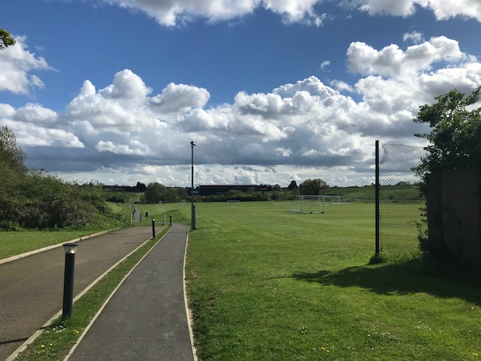

Existing porta cabins to be replaced by permanent WC/snack structures

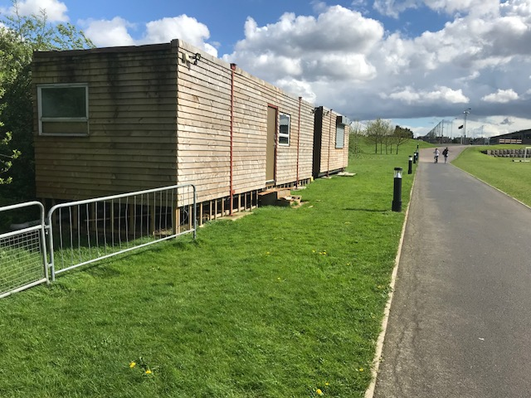

Existing north stand

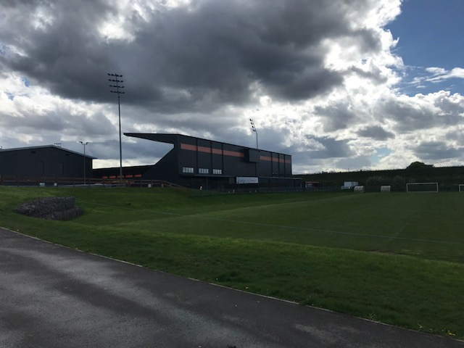

Existing north and east stands

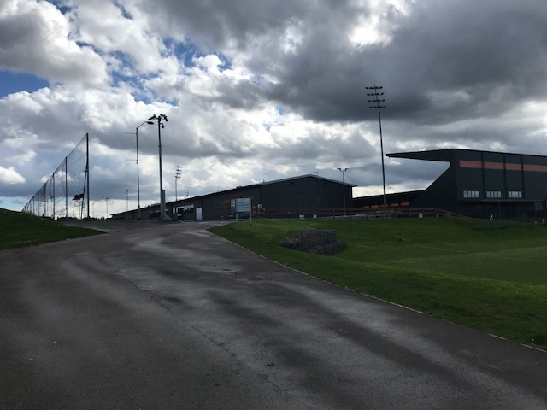

Existing temporary academy spectator stand

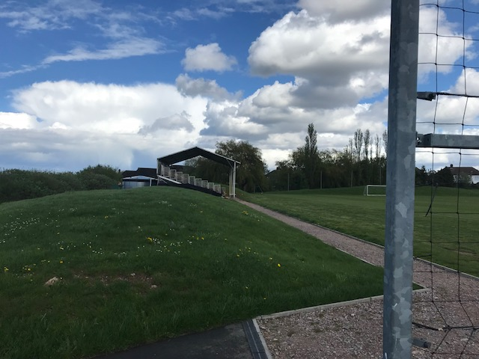

Road between Camrose Avenue gardens and bund/existing Astroturf pitches

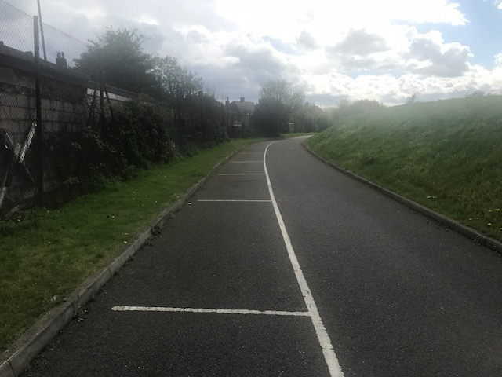

Looking northwards towards existing bund

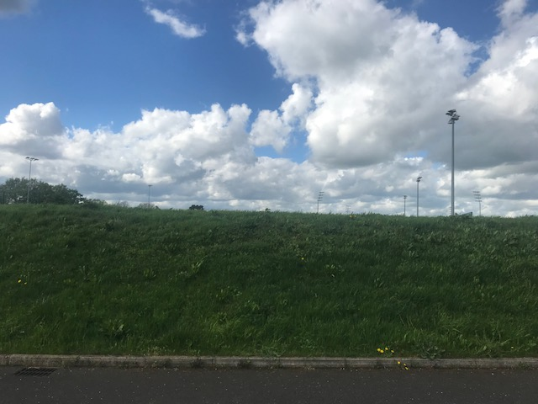

View of Camrose Avenue houses and gardens from top of existing bund

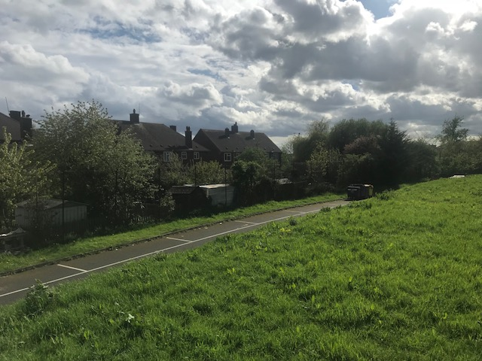

Existing Astroturf pitch to be enclosed by Academy building

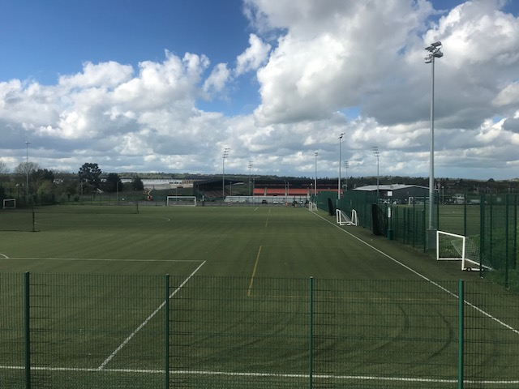

APPENDIX 4: PLANS AND ELEVATIONS

Proposed permanent academy spectator stand

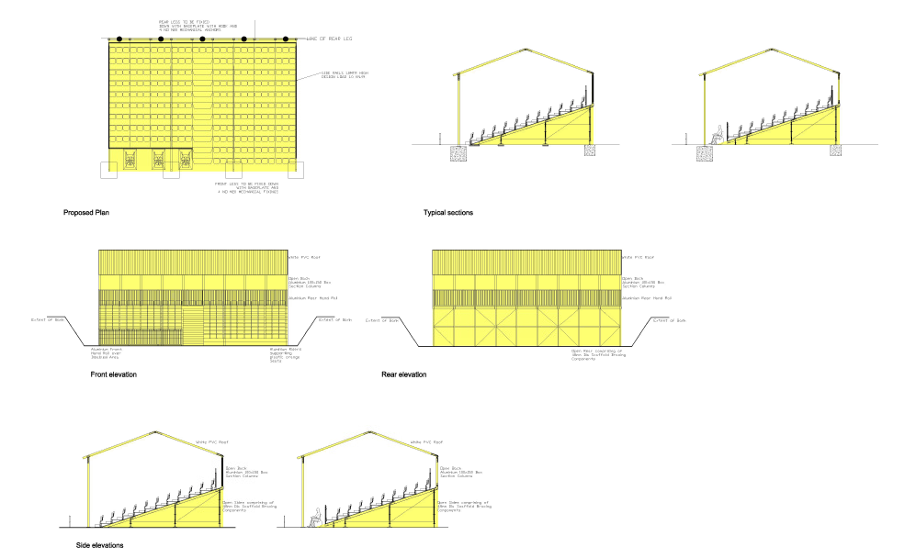

Proposed clubshop/ticket office
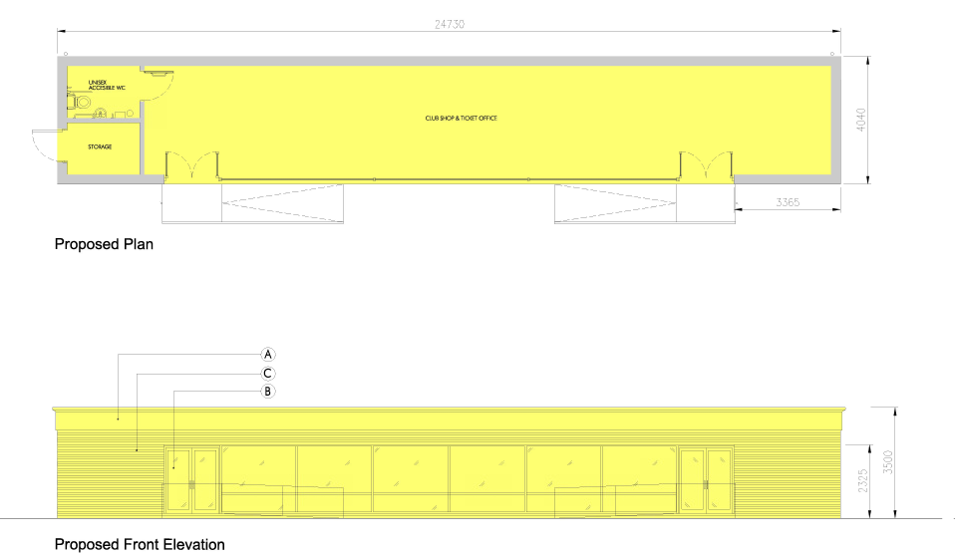

Proposed sports hall behind north stand
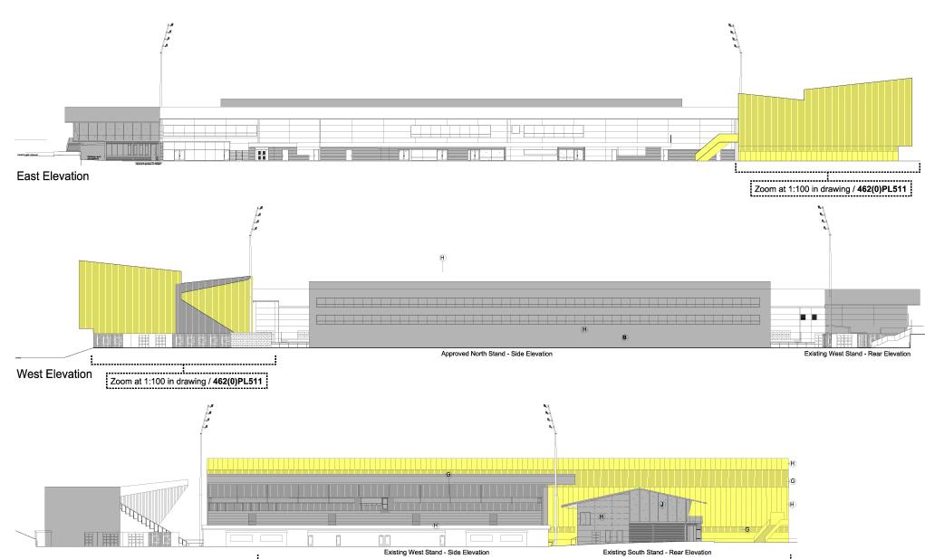

Proposed Academy building

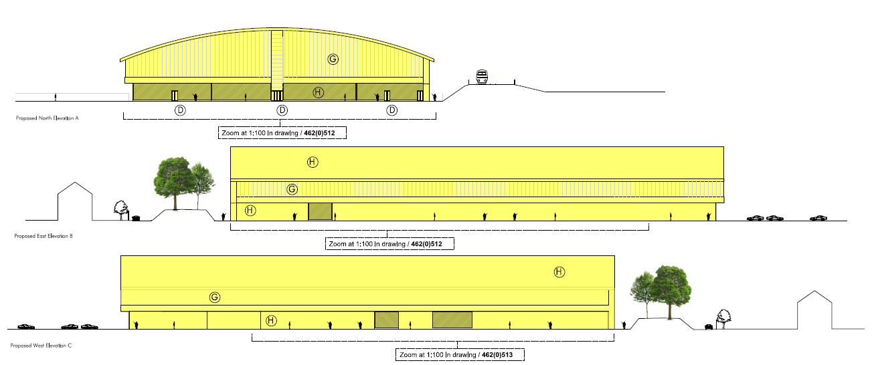

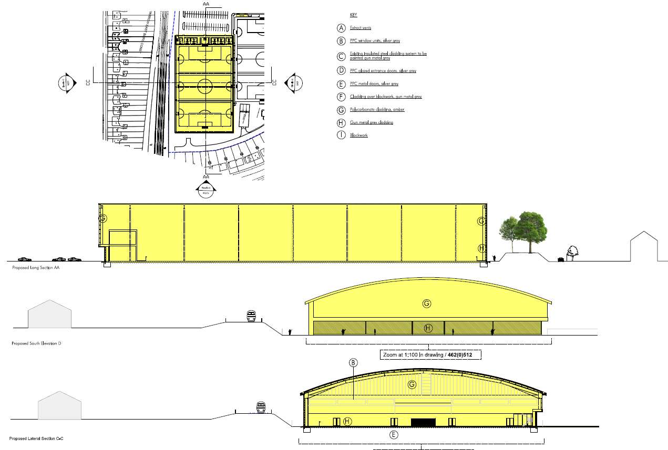

This page has been left intentionally blank

